**1. Introduction to industrial energy auditing**

An energy audit is a key to assessing the energy performance of an industrial plant and for developing an energy management program. The typical steps of an energy audit are:

• preparation and planning

• data collection and review

• plant surveys and system measurements

• observation and review of operating practices

• data documentation and analysis

• reporting of the results and recommendations

**1.1. Definition of energy auditing**

There are several relatively similar definitions of an energy audit. In its guidebook, CIPEC (2002) defines energy auditing as:

A systematic, documented verification process of objectively obtaining and evaluating energy audit evidence, in conformance with energy audit criteria and followed by communication of results to the client.

In the Indian Energy Conservation Act of 2001 (BEE 2008), an energy audit is defined as:

"The verification, monitoring and analysis of the use of energy and submission of technical report containing recommendations for improving energy efficiency with cost-benefit analysis and an action plan to reduce energy consumption."

**1.2. Objectives:** The objectives of an energy audit can vary from one plant to another. However, an energy audit is usually conducted to understand how energy is used within the plant and to find opportunities for improvement and energy saving. Sometimes, energy audits are conducted to evaluate the effectiveness of an energy efficiency project or program.

**1.3. Types of energy audits**

The type of industrial energy audit conducted depends on the function, size, and type of the industry, the depth to which the audit is needed, and the potential and magnitude of energy savings and cost reduction desired. Based on these criteria, an industrial energy audit can be classified into two types: a preliminary audit (walk-through audit) and a detailed audit (diagnostic audit).

**a) Preliminary audit (Walk-through audit):** In a preliminary energy audit, readily-available data are mostly used for a simple analysis of energy use and performance of the plant. This type of audit does not require a lot of measurement and data collection. These audits take a relatively short time and the results are more general, providing common opportunities for energy efficiency. The economic analysis is typically limited to calculation of the simple payback period, or the time required paying back the initial capital investment through realized energy savings.

**b) Detailed audit (Diagnostic audit):** For detailed (or diagnostic) energy audits, more detailed data and information are required. Measurements and a data inventory are usually conducted and different energy systems (pump, fan, compressed air, steam, process heating, etc.) are assessed in detail. Hence, the time required for this type of audit is longer than that of preliminary audits. The results of these audits are more comprehensive and useful since they give a more accurate picture of the energy performance of the plant and more specific recommendation for improvements. The economic analysis conducted for the efficiency measures recommended typically go beyond the simple payback period and usually include the calculation of an internal rate of return (IRR), net present value (NPV), and often also life cycle cost (LCC).

**1.4. Overview of energy audit procedures**

A preliminary audit (walk-through audit) contains some of the same steps of the procedure shown, but the depth of the data collection and analysis might be different depending on the scope and objectives of the audit. Overall, there are three main steps (excluding the post-audit activities) each of which has several sub-steps. These three main steps are energy audit preparation, execution, and reporting.

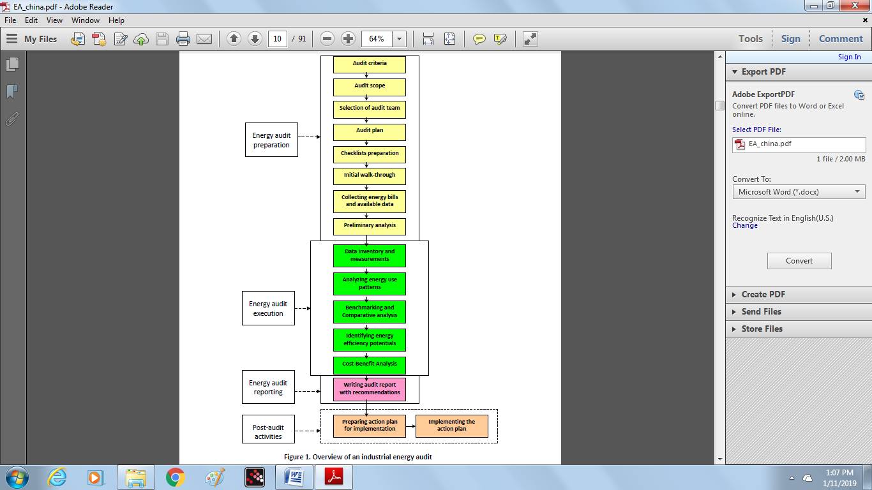

**2. Preparation for the energy audit**

**2.1. Defining the audit criteria**

Before starting the energy audit, the criteria against which the audit will be conducted should be defined. The following criteria should be taken into consideration:

• Audit objective

• Audit type

• Audit methodology and standards

• Staff involvement

• Site or utility boundary

• Timeline

• Reporting requirements

**2.2. Defining the audit scope**

The audit scope needs to consider the available resources such as staff, time, audit boundaries, level of analysis, expected results, the degree of detail, and the budget for conducting the energy audit. The audit scope will depend on the purpose of the specific audit and may be defined by an overall government or company audit program. It should also define the share of processes included in audit of plant’s total energy use as well as comprehensiveness and the level of detail for the final recommendations.

For large plants, defining the audit scope is an exercise by itself. The US DOE has developed the Quick Plant Energy Profiler (Quick PEP) tool to identify energy system(s) to include during the assessment and define the scope. The Quick PEP is an online software tool to help US industrial plants quickly understand how plant energy is being purchased and consumed and also helps identify potential cost and energy savings opportunities. The Quick PEP tool is meant to provide a broad overview of the energy profile for a plant and that the main purpose of the Quick PEP tool is to point the user to further resources and tools. Quick PEP is like a road map that helps the user understand the facility’s current energy situation and provides directions for exploring more targeted ways of saving energy and money (US DOE ITP, 2008).

**2.3. Selection of energy audit team**

The selection of the energy auditing team and energy auditors is a key decision for industrial plant managers. The plant’s top management, after consultation with the division managers of the plant, must decide whether the audit will be conducted by the plant’s internal staff or if an outside consultant should be hired. If a company has several plants, the staff in one plant can provide support for conducting energy audits in the other plants.

Energy auditors can be accredited separately for electrical and thermal energy audits, or for a complete energy audit of a site, according to their qualifications. When using an external auditor, it is better to choose the auditors accredited by government, non-government, or other authorized agencies.

The audit team leader determines the roles and responsibilities of the individual audit team members. If an outside consultant is chosen to conduct the audit, most of the audit team members will also be from outside of the plant (the staff of the consultant company conducting the audit) augmented by some staff within the plant and in the areas that will be audited that are assigned to cooperate with the energy auditors.

**2.4. Making an audit plan**

An audit plan outlines the audit strategy and procedure. The plan helps the auditors to check the consistency and completeness of the audit process and make sure nothing important is neglected or overlooked. The audit plan should provide the following (CIPEC 2009):

• Scope of the audit

• Time of the audit and its duration as well as the timeline for each step of the audit process

• Elements of the audit that have a high priority

• Responsibilities and tasks of each audit team member

• Format of the audit report and its outline

**2.5. Preparing an audit checklist**

The audit checklist helps the auditor to conduct the work in a systematic and consistent way. The checklist should include:

• Steps to be taken during the energy audit

• Data and information that should be collected

• Existing measurement instrument and the data recorded

• Required measurements during the energy audit and the list of parameters to be measured

• Major equipment to be assessed in more detail

• List of main components of the results section of the audit report, for guidance

• Other major concerns and considerations

**UNIT II SURVEY**

**2.6. Conducting the initial walk-through visit**

The purpose of the initial walk-through visit is for the energy audit team to become familiar with the facility to be audited. The auditors can go through the processes and utilities that they will audit in detail later. The audit team can observe the existing measurement instrumentation on the equipment and the data recorded, so that they can determine what extra measurement and data collection are required during the audit. This phase of the audit is quite useful, especially if the auditors are not made up of plant personnel. The audit team can also meet with the managers of the areas to be audited to provide an introduction and establish a common understanding of the audit process. The auditors can solicit comments from the facility staff and can collect readily-available data during the walk-through visit.

**2.7. Collecting energy bills and available data and information**

Energy bills along with other current and historical energy- and production-related data and information should be collected at the beginning of the audit process. The more historical data available, the better the auditor can understand the performance of the plant at differing times of day, in various seasons, and under diverse production conditions. The data that can be collected at the beginning of an energy audit include the followings:

• Energy bills and invoices (electricity and fuels) for the last 2 to 3 years

• Monthly production data for the last 2 to 3 years

• Climatic data for the period in which the auditing is conducted

• Possible archived records with measurements from existing recorders

• Architectural and engineering plans of the plant and its equipment

• Status of energy management and any energy-saving measures implemented

• General information about the plant (year of construction, ownership status, renovations, types of products, operation schedule, operating hours, scheduled shut-downs, etc.).

**2.8. Conducting the preliminary analysis**

The preliminary analysis helps the energy auditor to better understand the plant by providing a general picture of the plant energy use, operation, and energy losses. This effort provides enough information to undertake any necessary changes in the audit plan.

In the preliminary analysis, a flowchart can be constructed that shows the energy flows of the system being audited. An overview of unit operations, important process steps, areas of material and energy use, and sources of waste generation should be presented in this flowchart. The auditor should identify the various inputs and outputs at each process step. The preliminary flowchart is simple, but detailed information and data about the input and output streams can be added later after the detailed energy audit. An example of a preliminary flowchart for a textile dying plant is shown in Figure 2 below.

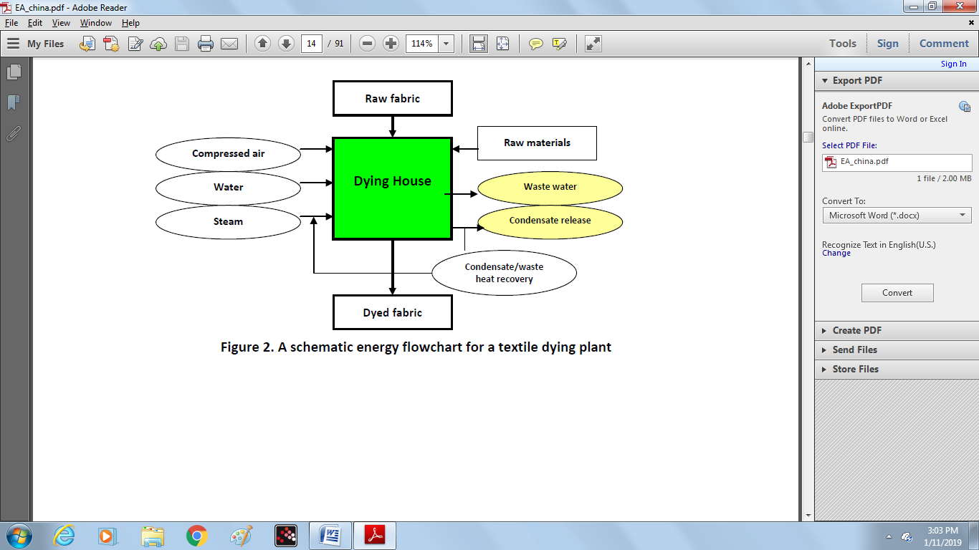

**3. Analyzing energy bills**

Energy bills, especially those for electricity and natural gas, are very useful for understanding and analyzing a plant’s energy costs. It is important to understand the different components of these bills, so that a correct and helpful analysis can be conducted.

**3.1. Electricity bills**

Several costs are usually included in the electricity bill. Most electric rates include a fixed service (or customer) charge that is constant regardless of the amount of electricity used, and a per kilowatt-hour (kWh) rate for the amount of electricity consumed. Most electricity bills (except for very small facilities) also include a demand charge per kilowatt (kW). The demand charge is based on the highest (or peak) electricity use each month, averaged over a short time period (usually 15 minutes). On some bills, demand cost and kWh cost are combined and shown as a single cost.

There is also a time-of-use charge in most industrial consumer electric bills. Based on the time in which the electricity is used, prices per kWh and per kW will vary. The other item in industrial electric bills is the charge for “reactive power” which is based on the types of electrical loads in a plant. For example, facilities with many electric motors may pay a penalty due to the increased electric transmission capacity needed for large inductive loads. Understanding rates is also important for planning energy-efficiency retrofits. To predict energy cost savings with the highest accuracy, savings must be calculated based on the time they occur and the rates in effect during each time period (California Energy Commission 2000).

Based on the data and information derived from the electricity bills, several calculations can be made. In some countries (e.g. some states in the US) the load at peak hours will determine in what tariff segment you will fall for all power used. Hence, reducing peak use may result in lower cost for energy (kWh) use. Furthermore, in some countries the power in some seasons is more expensive. For instance, in some European countries, the power in the winter is more expensive for companies since the use of electric heaters at residential sectors would increases the demand dramatically in the winter. Two other possible analyses are given below. In addition, demand profile analysis is discussed in more detail in section 5.

**Calculating electricity use per day (kWh/day)**

Electricity use in the period covered by the electricity bill can be divided by the number of the days given in the bill. Since reading periods in the bills can vary, kWh/day is more useful for identifying consumption trends than the total billed kWh. This can be used later to accurately calculate the monthly electricity use and can also be used for graphical analysis.

**Calculating the Load Factor (LF)**

The load factor is the ratio of the energy consumed during a given period (in the electricity bill) to the energy which would have been consumed if maximum demand had been maintained throughout the period.

Load factor (%) = $\frac{Energy used during the period (kWh)}{Maximum demand \left(kW\right)×Time under consideration (hr)} ×100$

Normally the load factor is less than 100%. That is, the energy consumed is less than the maximum power demand multiplied by the billing period. In general, if the load factor in a plant is reduced, the total cost of electricity will be higher. In other words, the load factor is a useful method of determining if a plant is utilizing its energy-consuming equipment on a consistent basis (higher LF), or using the equipment for a short duration (lower LF), thereby paying a demand penalty. Therefore, the plant’s load factor should be analyzed to determine the opportunity for improvement and demand control.

**3.2. Natural gas bills**

Natural gas bills might be different in various countries depending on the extent of market regulation. The following definitions are excerpted from CIPEC (2009) and are fairly standard, although these examples are for Canada. For definitions of specific terms in the natural gas bill of a plant, the auditor can contact the gas utility representative. The typical components of the bill are:

• ***Days***: Number of days covered by the current bill. This is important to note because the time between readings can vary anywhere within ± 5 days, making some monthly billed costs higher or lower than others.

• ***Reading date***: The “days used” and “reading date” can be used to correlate consumption or demand increases to production or weather factors.

• ***Contracted demand (CD)***: The pre-negotiated maximum daily usage, typically in m³/day.

• ***Overrun***: The gas volume taken on any day in excess of the CD (e.g. 105%).

• ***Customer charge***: A fixed monthly service charge independent of any gas usage or CD.

• ***Demand charge***: A fixed monthly charge based on the CD but independent of actual usage.

• ***Gas supply charge***: The product charge (cents per m³) for gas purchased; commonly called the commodity charge. This is the competitive component of the natural gas bill. If a plant purchases gas from a supplier (not the gas utility to which it is connected), this charge will be set by that contract or supplier. The gas utility will also offer a default charge in this category.

• ***Delivery charge (re CD)***: A fixed monthly charge based on the CD but independent of actual usage.

• ***Delivery (commodity) charge (for gas delivered)***: The fixed or block delivery charge (cents per m³) for gas purchased.

• ***Overrun charge***: The rate paid for all gas purchased as overrun.

**3.3. Coal and fuel oil bills**

The actual use of coal and fuel oil is difficult to track accurately because consumption is not usually metered. Monthly consumption is typically estimated based on fuel delivery dates and may not correspond to actual consumption. Coal consumption can be estimated from the combustion efficiency and energy output of coal-fired equipment. Oil consumption can be obtained from meters on the outflow of oil storage tanks if such meter exists. If the meter is not installed on fuel oil consuming equipment, then the same method for the estimation of coal consumption can also be used for fuel oil as well.

**3.4. Graphical analysis of historical energy use**

Graphical analysis of hourly/daily/monthly/yearly energy use for each type of energy used in a plant can help to better understand the energy use pattern in the plant. Sometimes the patterns are unexpected and can lead to opportunities to modify the way energy is used and save energy. For example, one might not normally expect a heavy process industry like cement industry to exhibit a seasonal variation in energy use because of weather changes. Despite this, if a seasonal pattern shows up in the graphical analysis, this may suggest the need to investigate for the possible sources of energy losses.

It is common for a plant’s operating conditions or capacities to vary over the year. Therefore, the variation of energy use alone may not truly reflect the condition of energy efficiency in a plant. Thus, it is much better and more accurate to conduct this type of graphical analysis of a plant’s energy intensity (EI), which is the energy use per unit of production. Energy intensity can be calculated by using monthly energy consumption data obtained from energy bills and the monthly production data.

Energy Intensity (kWh or GJ/ tonne) = $\frac{Energy Consumption (kWh or GJ)}{Production (tonne)}$

A hypothetical example of energy intensity for electricity and fuel use in a textile spinning plant in a four-season country is provided in Figure 3. As can be seen, the electricity intensity pattern over the year does not vary much, whereas the fuel intensity pattern varies by the change in seasons. The reason is that in a spinning plant, fuel is used just for heating during the cold months, as the temperature and moisture of the spinning plants needs to be kept constant all over the year.

A pie chart is another type of chart that can be used for graphical analysis of historical energy use and cost data. A pie chart can be used to show the share of various types of energy use and their costs graphically. Both monthly and annual data can be used for plotting such graph (Hooke et al. 2003). Figure 4 shows a hypothetical example of the share of each type of final energy2 also the share of each type’s cost in relation to the total annual energy cost. As can be seen from Figure 4, although coal accounts for 60% of final energy use, it is only 35% of total energy cost. On the other hand, electricity represents the highest share of annual energy cost, while only accounting for 20% of total energy consumption.

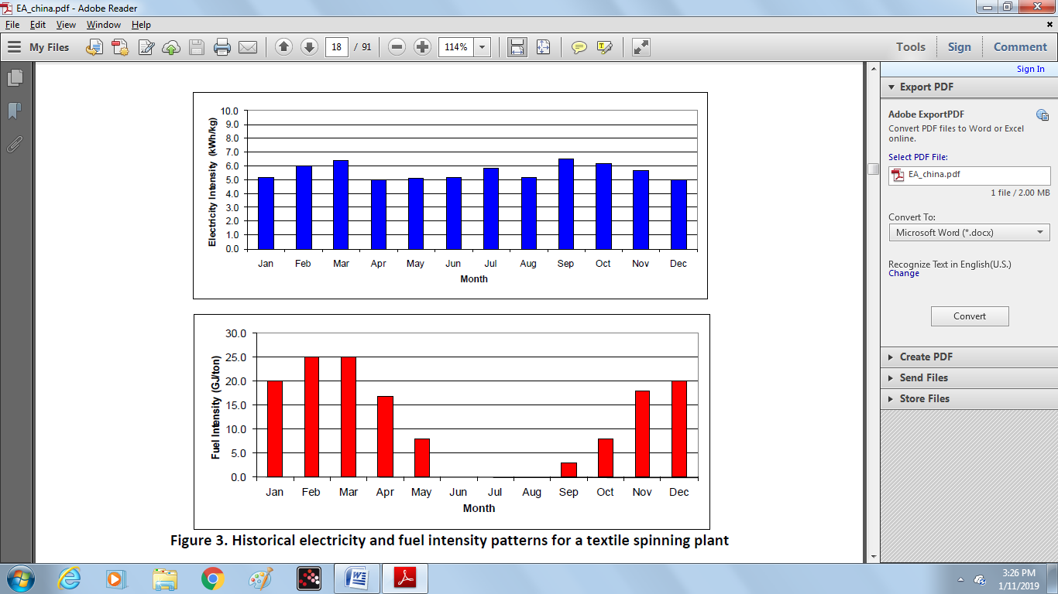

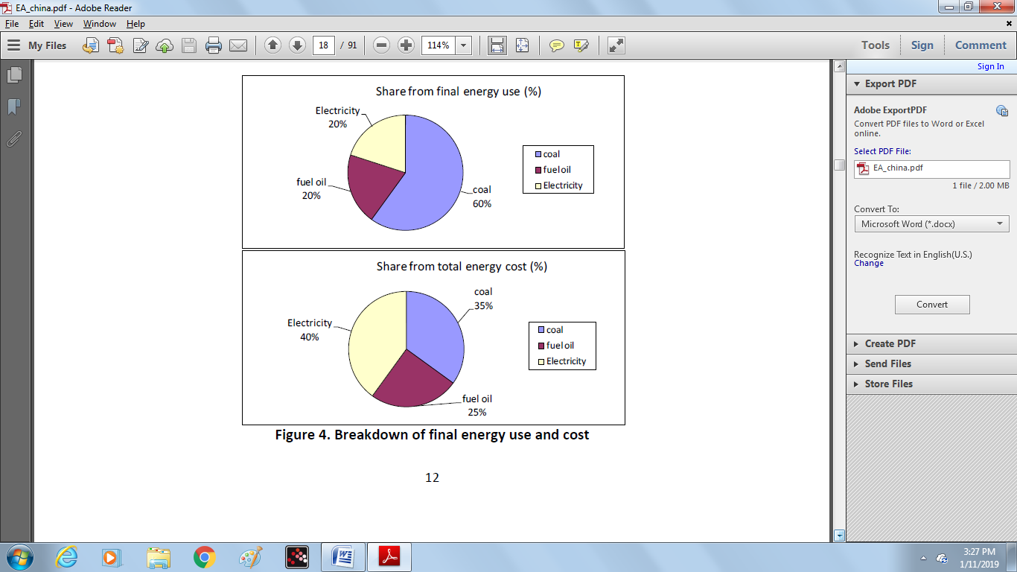

**UNIT III INVENTORY AND PRODUCTION PATTERNS**

**4. Inventory and measurement of energy use**

Gathering data through an inventory and measurement is one of the main activities of energy auditing. Without adequate and accurate data, an energy audit cannot be successfully accomplished. Some data are readily available and can be collected from different divisions of the plant being audited. Some other data can be collected through measurement and recording. The energy audit team should be well-equipped with all of the necessary measurement instruments. These instruments can be portable or installed in certain equipment (CRES 2000). The most common data measured during the auditing process are:

• Liquid and gas fuel flows

• Electrical measurements, such as the voltage, current intensity and power, as well as power factor

• Temperatures of solid and liquid surfaces

• Pressure of fluids in pipes, furnaces or vessels

• Exhaust gases emissions (CO2, CO, O2 and smoke)

• Relative humidity

• Luminance levels

In Appendix 2 of this report (Energy Audit Instruments), commonly-used measurement instruments for industrial energy auditing are explained in more detail. Additional information on measurement and metering can also be found in Hooke et al. (2003). The remainder of this section focuses on the type of measurement that should be conducted and the analyses that can be made from those measurements in both electrical and thermal utilities. This is useful for the energy auditors and can help them to follow a systematic approach in order to assess the energy use and performance in an industrial plant. In this guidebook, the analysis is focused on an electrical load inventory and a thermal energy use inventory.

**4.1. Electrical load inventory**

Making an inventory of all electrical loads in a plant aims to answer two important questions: where the electricity is used? How much and how fast is electricity used in each category of load? One way to prioritize the electricity-saving opportunities is by the magnitude of the loads. Therefore, identifying and categorizing different loads in a plant can be useful. Because the inventory of the loads also quantifies the demand (i.e. how fast electricity is used) associated with each load or group of loads, it is valuable for further interpretation of the demand profile. The demand profile is further discussed in Section 5 of this guidebook. To conduct an electrical load inventory in an industrial plant, an auditor can follow the 8 steps explained in CIPEC (2009).

**4.2. Thermal energy use inventory**

An energy flow diagram like the one shown in Figure 2 is helpful for identifying thermal energy flows. The energy flow chart can show all energy flows into the facility, all outgoing flows from the facility to the environment, and all significant energy flows within the facility. The purpose of an energy flow diagram is not to describe a process in detail. In fact, it will generally not show specific devices and equipment that are found in its various sub-systems. The sum of the energy outflows should equal energy inflows. With this information, it is often possible to see opportunities for energy saving and recovery.

**Identifying the type of energy flow:**

Table 1 provides a checklist for identifying the thermal energy outflows from a subsystem or a facility. This list of the thermal energy outflows is not exhaustive, but does include the major thermal energy flows where energy efficiency potentials often are found.

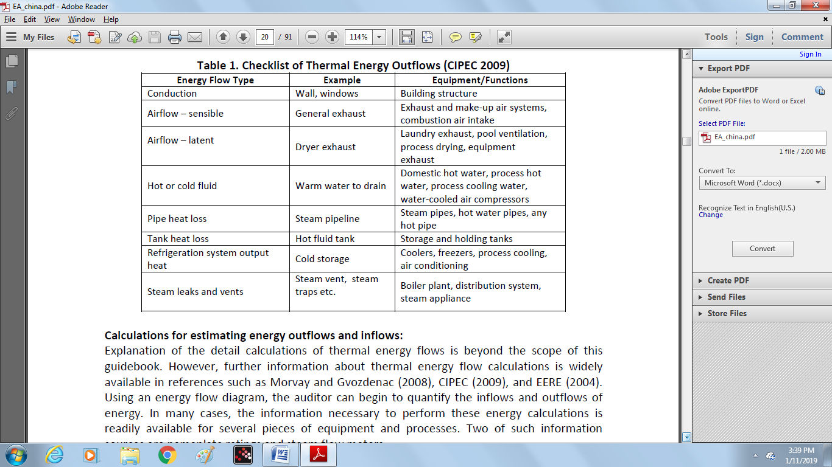

**Calculations for estimating energy outflows and inflows:**

Explanation of the detail calculations of thermal energy flows is beyond the scope of this guidebook. Using an energy flow diagram, the auditor can begin to quantify the inflows and outflows of energy. In many cases, the information necessary to perform these energy calculations is readily available for several pieces of equipment and processes. Two of such information sources are nameplate ratings and steam flow meters.

**4.3. Energy system-specific measurements**

There are different types of energy systems in a plant such as pumping, fan, compressed air, steam, and process heating systems. Each of these systems has their own unique characteristics and they often require different measurement techniques and instruments. The American Society of Mechanical Engineers (ASME) has published energy assessment standards that cover the assessment of pumping, compressed air, steam, and process heating systems.

**4.4. Energy balance**

One of the advantages of an energy balance is that all energy inputs can be quantified and balanced against all energy outputs. A convenient graphical representation of this is the Sankey diagram. In a Sankey diagram, the energy losses/outflows, the energy gains/inflows, as well as the useful energy in a given energy system are represented quantitatively and in proportion to the total energy inflow, according to existing data from energy bills and invoices, calculations and in-site measurements in the plant. Presenting the energy flows visually with the aid of the Sankey diagram helps to locate the more critical energy-consuming areas of the energy system and, at the same time, to identify the sources that lead to energy losses. Figure 5 provides an example of Sankey diagram of energy flows. A Sankey diagram can be simply drawn by hand. However, there are also special software packages for the creation of the Sankey diagram.

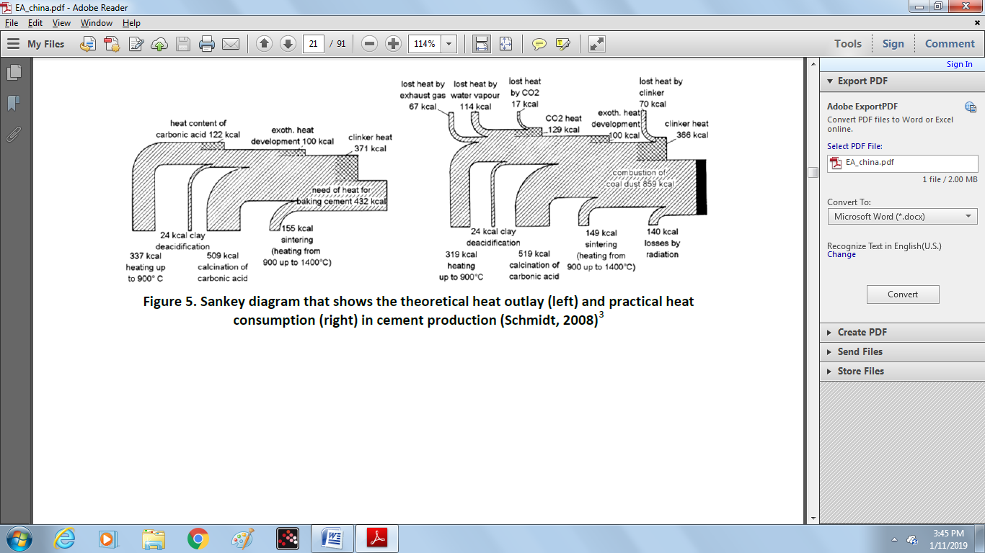

**5. Analyzing energy use and production patterns**

**5.1. Load/Demand profile**

Electricity loads can change over time based on changes in end-user demand. A graph showing the load shape of a device or equipment over time is known as load/demand profile or diagram. If such a diagram is plotted for the load requirements of all the electricity-using equipment in a plant, it can be useful for determining the characteristics of the power requirements and for understanding the power supply economics. In fact, the shape of the load diagram is the source of major billing items on electricity bills and the basis for various tariff system charges. A sample of a daily load profile is shown in Figure 6. The shape of the load profile depends on the working arrangements and the nature of the processes and the energy systems in the plant being audited. For example, if a facility runs three shifts, the load profile could be fairly flat, whereas if the company works just one or two shifts, the 24 hour load profile will have peaks and valleys as shown in the figure below.

The load profile can be monthly, daily, hourly or, if possible, more frequently. The time interval of a load profile depends on the purpose of the final analysis for which the load profile is needed. Most of the electricity bills provide enough information required for the development of the monthly load profile. Table 2 provides some useful information that can be derived from the load profile.

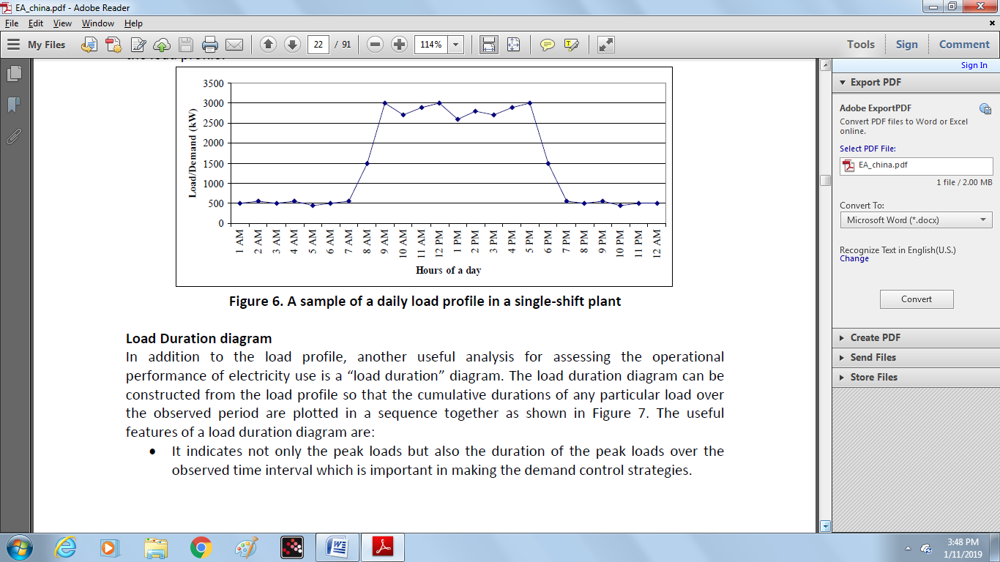

**Load Duration diagram**

In addition to the load profile, another useful analysis for assessing the operational performance of electricity use is a “load duration” diagram. The load duration diagram can be constructed from the load profile so that the cumulative durations of any particular load over the observed period are plotted in a sequence together as shown in Figure 7. The useful features of a load duration diagram are:

• It indicates not only the peak loads but also the duration of the peak loads over the observed time interval which is important in making the demand control strategies.

• It provides an insight into variable and fixed demand which provides a basis for determining operational performance. Ideally, variable demand is caused only by production variability, while fixed demand reflects the unavoidable minimum consumption that occurs regardless of production output. In reality, however, neither of these would be the case. There is often a good opportunity to reduce both the fixed and variable portions of the demand in industrial plants. There are the common cases of so-called “false” fixed demand when certain loads are operated as fixed although in reality such operations are not always required.

• It also helps to determine the load during the non-production hours in order to reduce the energy use. It is often possible to determine the significant energy saving opportunity since some equipment might be working during non-production hours unnecessarily.

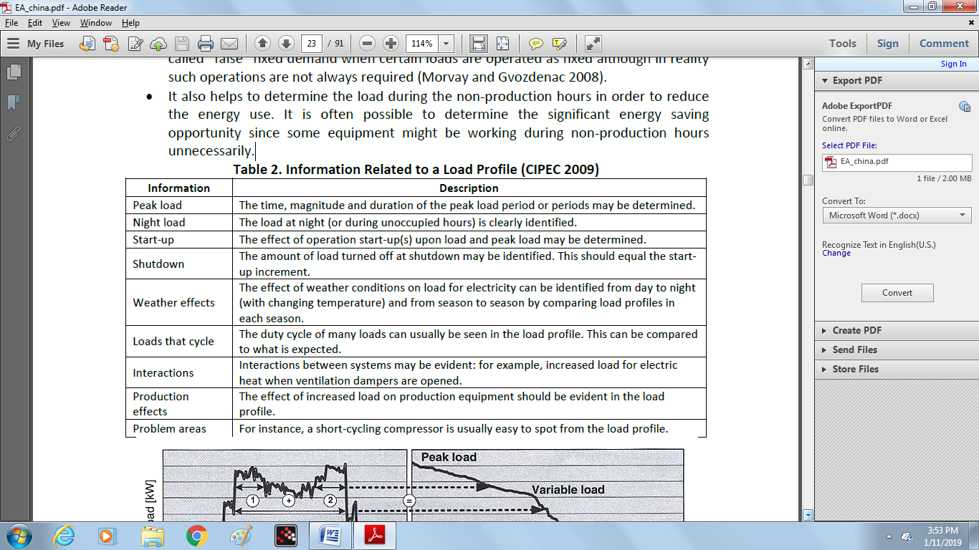

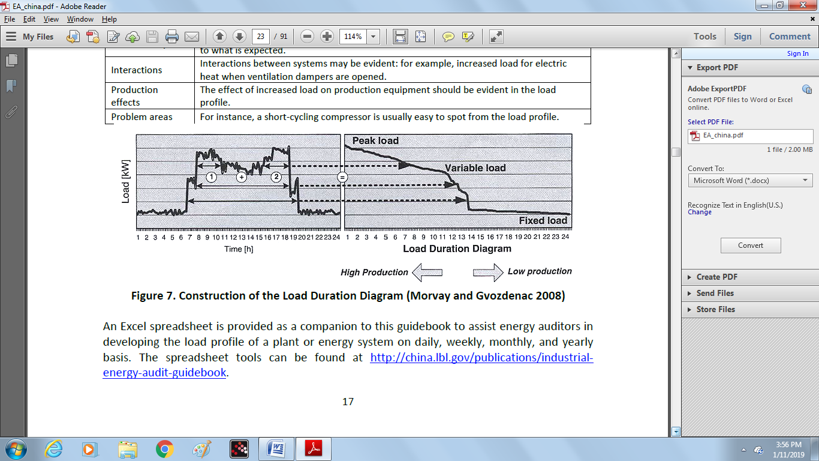

It should be noted that the daily load profile can be constructed for several consecutive days. In the spreadsheet for daily and monthly load profile, the template for creating a load duration diagram is also provided.

**5.2. Scatter diagram for presenting the dynamics of the energy-production relationship**

Variations in energy use are to some extent due to production variability. However, often excessive variation in energy use occurs that cannot be explained by the variation in production. In this case, the cause of such excessive variation can be identified by using various techniques some of which are explained below. For this purpose, the energy and production data and adequate knowledge of the production process is required. In section 3.4, how electricity and fuel intensity patterns can be constructed and interpreted is briefly explained.

A scatter diagram in which production is presented on the x-axis as an independent variable and energy is presented on the y-axis as a dependent variable provides useful information on the underlying relationship between energy use and production. An example of a scatter diagram of monthly energy use and production is shown in Figure 8. Such a scatter diagram does not have any time dimension. If production varies, it is expected that the energy use will vary as well. The position of each point in the scatter diagram is the result of explainable causes and production circumstances that have occurred during the observed period. When the energy use–production relationship is visualized in a scatter diagram, variations in performance become visible immediately and the auditor can begin to interpret the variation and take action. Next, qualitative analysis and interpretation of the energy-production relationship as provided by the scatter diagram is discussed. This is followed by an explanation of useful statistical methods for analysis of the data on the scatter diagram.

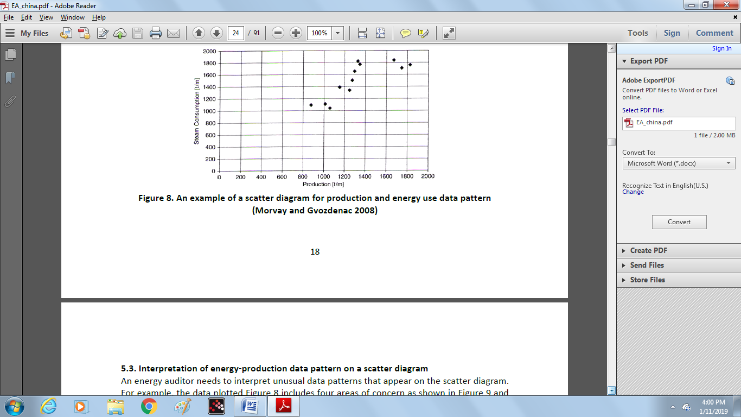

**5.3. Interpretation of energy-production data pattern on a scatter diagram**

An energy auditor needs to interpret unusual data patterns that appear on the scatter diagram. For example, the data plotted Figure 8 includes four areas of concern as shown in Figure 9 and explained below:

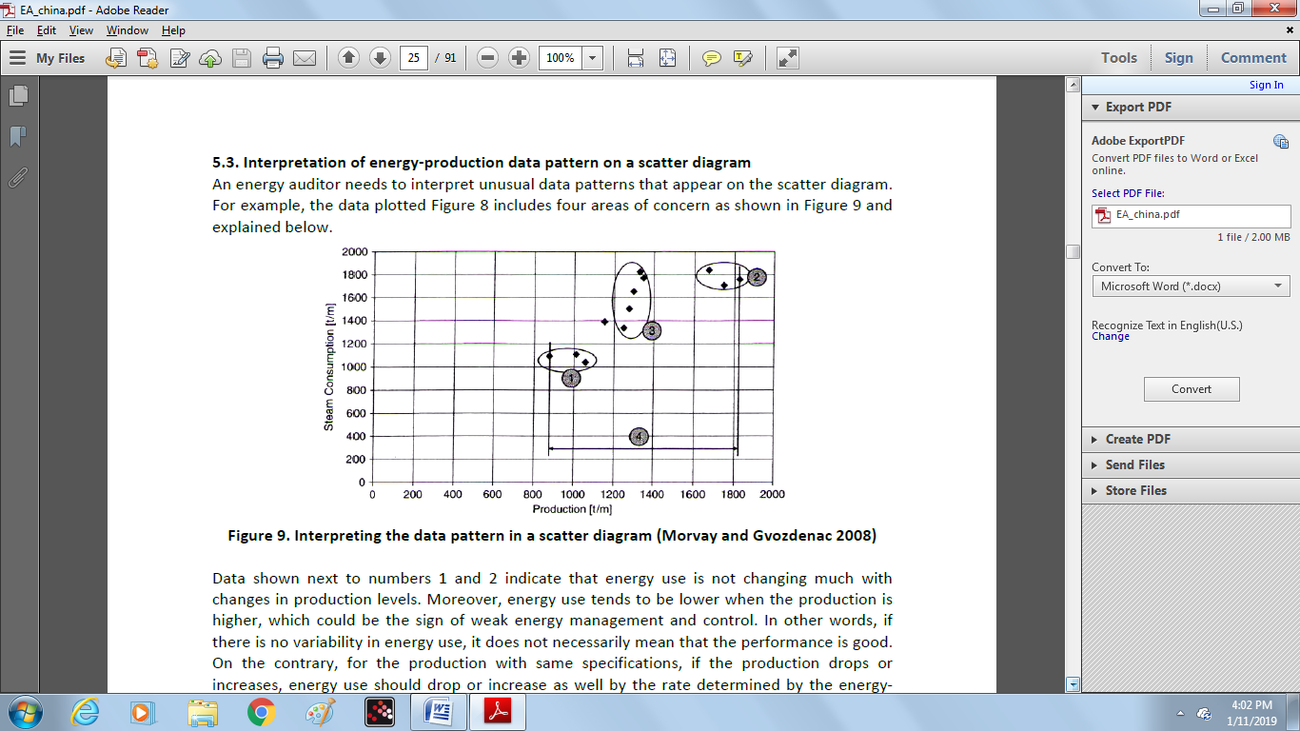

Data shown next to numbers 1 and 2 indicate that energy use is not changing much with changes in production levels. Moreover, energy use tends to be lower when the production is higher, which could be the sign of weak energy management and control. In other words, if there is no variability in energy use, it does not necessarily mean that the performance is good. On the contrary, for the production with same specifications, if the production drops or increases, energy use should drop or increase as well by the rate determined by the energy-production relationship. Data shown next to number 3 indicate that for almost the same production output, there are several different points of recorded energy use ranging from 1300 to 1800 tons of steam. In this case, the energy auditor should ask “if 1300 tons of steam is enough for the production, why is it not always enough?” Basically, if the production is steady, the energy use should also be steady, as long as the production specifications are unchanged.

Data shown next to number 4 indicate a range of recorded production which varies from 876 to 1825 tons/month. This is very large production variability. Sometimes, the specific energy consumption is higher (i.e. poorer energy performance) when production is lower because of the low capacity utilization in the plant. Normally, if production varies often and to a great extent, it can be difficult to maintain energy use at the optimum level; thus greater variations in energy use will happen. However, sometimes production variability is beyond the plant’s control because its level is set by market demand. However, such problems can also be shown when daily production and energy data are used to construct scatter diagrams. Through better production planning, daily production can be controlled and the large variation can be avoided. If production requirements are set below the maximum capacity, there is an option to operate machinery at full capacity for a shorter period of time rather than for full time at partial capacity.

A scatter diagram visualizes energy use patterns and can be used for qualitative analysis as explained above, but it does not provide quantitative information. To conduct the quantitative analysis, the statistical methods such as regression analysis should be applied. Some of these statistical methods are explained in Morvay and Gvozdenac (2008), CIPEC (2009), CenterPoint Energy (2004), and US Environmental Protection Agency (2007a).

**6. Benchmarking and comparative energy performance analysis**

Energy efficiency benchmarking and comparisons can be used to assess a company’s performance relative to that of its competitors or its own performance in the past. Benchmarking can also be used for assessing the energy performance improvement achieved by the implementation of energy-efficiency measures. Also, on a national level, policy makers can use benchmarking to prioritize energy-saving options and to design policies to reduce greenhouse gas emissions. International comparisons of energy efficiency can provide a benchmark against which a company’s or industry’s performance can be measured to that of the same type of company or industry in other countries.

Benchmarking energy performance of a facility enables energy auditors and managers to identify best practices that can be replicated. It establishes reference points for managers for measuring and rewarding good performance. It identifies high-performing facilities for recognition and prioritizes poor performing facilities for immediate improvement. Benchmarking can be done in variety of ways. Plant performance may be benchmarked to:

• **Past performance**: comparing current versus historical performance.

• **Industry average**: comparing to on an established performance metric, such as the recognized average performance of a peer group.

• **Best in class**: benchmarking against the best in the industry and not the average.

• **Best Practices**: qualitative comparing against certain, established practices or groups of technologies considered to be the best in the industry.

The key steps in benchmarking include:

• Determine the level of benchmarking (for example, technology, process line, or facility)

• Develop metrics: select units of measurements that effectively and appropriately express energy performance of the plant (e.g. kWh/ton product, GJ/ton product, kgce/ton product, etc.)

• Conduct comparisons to determine the performance of the plant or system being studied compare to the benchmark.

• Track performance over time to determine if energy performance being improved or worsening over time in order to take the appropriate actions.

While conducting benchmarking, the key drivers of energy use should be identified and the benchmarking metrics might be adjusted or normalized, for instance, based on the weather, production levels, or product characteristics that affect energy use. Normalizing data ensures a meaningful comparison and avoids comparing “apples to oranges.” Evaluating and acting on benchmarking results are as important as undertaking the benchmarking activity. Successful benchmarking also requires monitoring and verification methods to ensure continuous improvement (US EPA 2008c).

There are a few benchmarking tools that can be used by energy auditors and managers to conduct benchmarking in industrial facilities. However, these tools are currently only available for selected industrial sectors and/or for use in specific countries.

Through the ENERGY STAR for Industry program, the US Environmental Protection Agency (EPA) has developed plant energy performance indicators (EPI) to enable energy auditors, managers, and corporate executives to evaluate the energy efficiency of industrial plants against similar facilities in the US. Users input plant operating data and receive an energy-efficiency rating for a plant on a scale of 1 to 100. EPIs are currently available for: cement manufacturing, container glass manufacturing plants, corn refining, flat glass manufacturing plants, frozen fried potato processing plants, juice processing plants, motor vehicle manufacturing, and pharmaceutical manufacturing. The EPI tools can be downloaded free of charge from US EPA (2008a).

Another benchmarking tool is the Benchmarking and Energy Savings Tool (BEST) for Cement industry which was developed by Lawrence Berkeley National Laboratory (LBNL) in collaboration with the Energy Research Institute (ERI) and other partners in China. BEST-Cement is a process-based benchmarking tool based on commercially available energy-efficiency technologies used anywhere in the world applicable to the cement industry. The current version has been designed for use in China and benchmarks cement facilities to both Chinese and international best practice. However, it can also be used in other countries with small modifications. BEST-Cement for China is in both English and Chinese language and can be downloaded from LBNL & ERI (2008).

Lawrence Berkeley National Laboratory also developed another benchmarking tool called BEST-Winery. It compares the performance of a target winery plant to a similar reference winery. BEST-Winery’s reference winery is based on a very efficient winery using state-of-the art but commercially available energy- and water-efficient technologies. The BEST-Winery tool and its handbook are available free of charge from LBNL (2007).

The Canadian Industry Program for Energy Conservation (CIPEC) has also developed and published series of energy benchmarking and best practices guidebooks for several industrial sectors such as pulp and paper mills, steel industry, ammonia industry, potash production facilities, salt-and-dry fish processing and lobster processing, automotive parts industry, and textiles wet processing. These guidebooks are available free of charge from CIPEC (2009b).

**7. Identifying energy efficiency and energy cost reduction opportunities (Introduction)**

There are various energy systems that can be found in almost all industrial plants such as motor systems, steam systems, compressed-air systems, pumps, and fan systems. These are so-called “cross-cutting” technologies. In addition, each industrial sub-sector has its own unique production technologies and processes. Energy-efficiency improvement opportunities can be found in both cross-cutting as well as industry-specific areas. Since there are many industrial sectors with numerous types of technologies and machinery, it is beyond the scope of this guidebook to discuss in detail the energy-efficiency opportunities for each technology, system, or industry.

This section first explains how a load profile (described in section 5) can be used for energy cost reduction. Then, the list of energy-efficiency measures for cross-cutting technologies that can be further analyzed by energy auditors if applicable to the industrial plant being audited is briefly presented. Detailed explanation of specific energy-efficiency measures can be found in the references given for each section. Finally, references are given for the publications on sector-specific energy-efficiency measures for various industrial sectors that can be used by energy auditors to go beyond the cross-cutting technologies and identify the energy saving opportunity in the process.

**UNIT IV ANALYSIS OF DATA**

**7.1. Electrical demand control**

Demand control is a follow-up analysis that is normally conducted by energy auditors after development of a demand or load profile. Demand control is simply a technique for leveling out the load profile diagram, i.e. “shaving” the peaks and “filling” the valleys (Figure 10). The main advantage of demand control and load management is the reduction of electricity cost. In practice, the demand limit of a plant is higher than the average electricity requirement since it is rarely possible to operate with constant power consumption. The first step in demand control schemes is to analyze the electricity utility tariff structure and past history of power demand in the plant. The concept of the load factor explained in section 3 is a useful tool in demand control analysis. Maximum demand and total kilowatt-hours are easily obtained from past electricity bills.

The simplest method for reducing peak loads is to schedule production activities so that the largest electrical power users do not operate at the peak time at all, or at least some do not operate at the same time if possible. *Machine scheduling* is the practice of turning equipment on or off depending on the time of day, day of week, day type, or other variables and production needs. Improved machine scheduling is achieved through efficient production planning that takes into account the energy aspect of the production. This is one of the most effective ways to avoid machine idling and to reduce peak demand. A second method relies on automatic controls which shut down non-essential loads for a predetermined period during peak time by means of some load management devices such as simple switch on-off devices, single load control device, demand limiters, or computerized load management system.

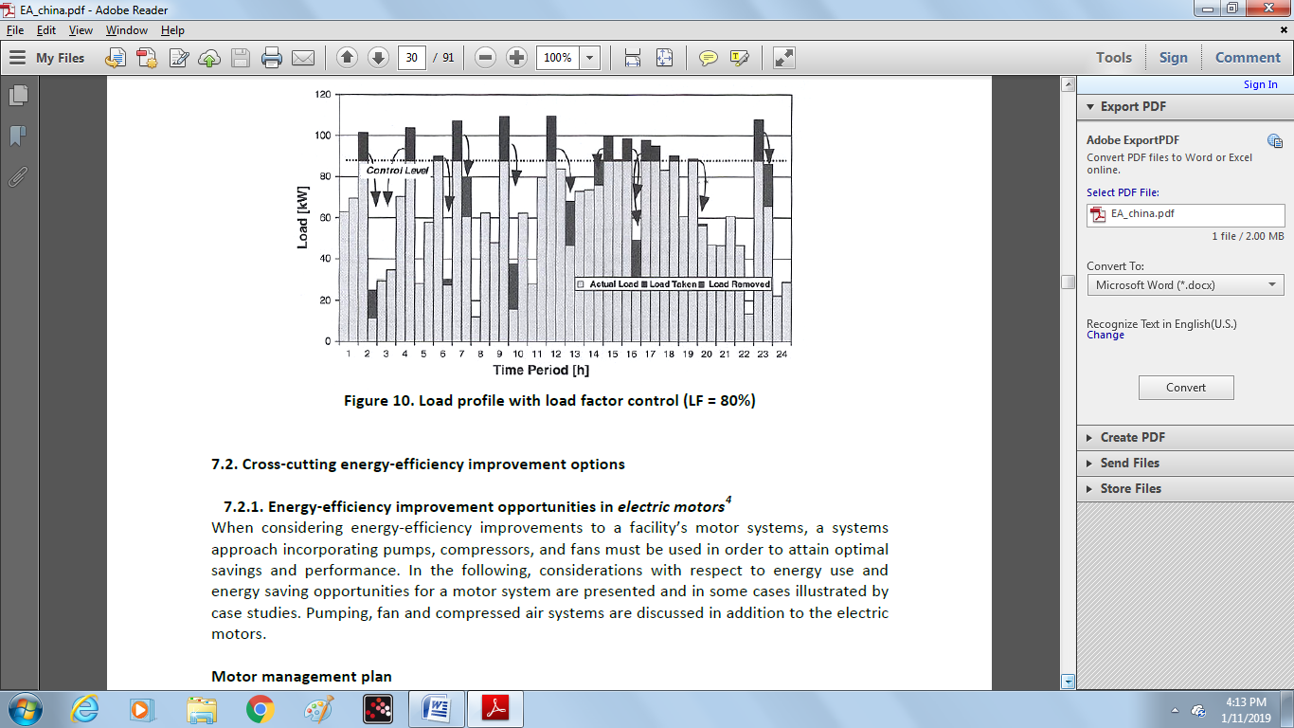

**7.2. Cross-cutting energy-efficiency improvement options**

**7.2.1. Energy-efficiency improvement opportunities in *electric motors***

When considering energy-efficiency improvements to a facility’s motor systems, a systems approach incorporating pumps, compressors, and fans must be used in order to attain optimal savings and performance. In the following, considerations with respect to energy use and energy saving opportunities for a motor system are presented and in some cases illustrated by case studies. Pumping, fan and compressed air systems are discussed in addition to the electric motors.

**Motor management plan**

A motor management plan is an essential part of a plant’s energy management strategy. Having a motor management plan in place can help companies realize long-term motor system energy savings and will ensure that motor failures are handled in a quick and cost effective manner. The Motor Decisions MatterSM Campaign suggests the following key elements for a sound motor management plan (CEE, 2007):

1. Creation of a motor survey and tracking program.

2. Development of guidelines for proactive repair/replace decisions.

3. Preparation for motor failure by creating a spares inventory.

4. Development of a purchasing specification.

5. Development of a repair specification.

6. Development and implementation of a predictive and preventive maintenance program.

**Maintenance**

The purposes of motor maintenance are to prolong motor life and to foresee a motor failure. Motor maintenance measures can therefore be categorized as either preventative or predictive. Preventative measures, include voltage imbalance minimization, load consideration, motor alignment, lubrication and motor ventilation. Some of these measures are further discussed below. Note that some of them aim to prevent increased motor temperature which leads to increased winding resistance, shortened motor life, and increased energy consumption. The purpose of predictive motor maintenance is to observe ongoing motor temperature, vibration, and other operating data to identify when it becomes necessary to overhaul or replace a motor before failure occurs.

The savings associated with an ongoing motor maintenance program could range from 2% to 30% of total motor system energy use (Efficiency Partnership, 2004).

**Energy-efficient motors**

Energy-efficient motors reduce energy losses through improved design, better materials, tighter tolerances, and improved manufacturing techniques. With proper installation, energy-efficient motors can also stay cooler, may help reduce facility heating loads, and have higher service factors, longer bearing life, longer insulation life, and less vibration.

The choice of installing a premium efficiency motor strongly depends on motor operating conditions and the life cycle costs associated with the investment. In general, premium efficiency motors are most economically attractive when replacing motors with annual operation exceeding 2,000 hours/year. Sometimes, even replacing an operating motor with a premium efficiency model may have a low payback period. According to data from the Copper Development Association, the upgrade to high-efficiency motors, as compared to motors that achieve the minimum efficiency as specified by the Energy Policy Act of 1992 can have paybacks of less than 15 months for 50 hp motors (CDA, 2001).

**Rewinding of motors**

In some cases, it may be cost-effective to rewind an existing energy-efficient motor, instead of purchasing a new motor. As a rule of thumb, when rewinding costs exceed 60% of the costs of a new motor, purchasing the new motor may be a better choice (CEE, 2007).

When repairing or rewinding a motor, it is important to choose a motor service center that follows best practice motor rewinding standards in order to minimize potential efficiency losses. Such standards have been offered by the Electric Apparatus Service Association (EASA) (EASA, 2006). When best rewinding practices are implemented, efficiency losses are typically less than 1% (EASA, 2003).

**Proper motor sizing**

It is a persistent myth that oversized motors, especially motors operating below 50% of rated load, are not efficient and should be immediately replaced with appropriately sized energy-efficient units. In actuality, several pieces of information are required to complete an accurate assessment of energy savings. They are the load on the motor, the operating efficiency of the motor at that load point, the full-load speed (in revolutions per minute [rpm]) of the motor to be replaced, and the full-load speed of the downsized replacement motor

The efficiency of both standard and energy-efficient motors typically peaks near 75% of full load and is relatively flat down to the 50% load point. Motors in the larger size ranges can operate with reasonably high efficiency at loads down to 25% of rated load. There are two additional trends: larger motors exhibit both higher full- and partial-load efficiency values, and the efficiency decline below the 50% load point occurs more rapidly for the smaller size motors.

**Adjustable speed drives (ASDs)**

Adjustable-speed drives better match speed to load requirements for motor operations, and therefore ensure that motor energy use is optimized to a given application. As the energy use of motors is approximately proportional to the cube of the flow rate 6 , relatively small reductions in flow, which are proportional to pump speed, already yield significant energy savings.

Adjustable-speed drive systems are offered by many suppliers and are available worldwide. Worrell *et al.* (1997) provides an overview of savings achieved with ASDs in a wide array of applications; typical energy savings were shown to vary between 7% and 60% with estimated simple payback periods for ranging from 0.8 to 2.8 years.

**Power factor correction**

Power factor is the ratio of working power to apparent power. It measures how effectively electrical power is being used. A high power factor signals efficient utilization of electrical power, while a low power factor indicates poor utilization of electrical power. Inductive loads like transformers, electric motors, and HID lighting may cause a low power factor. The power factor can be corrected by minimizing idling of electric motors (a motor that is turned off consumes no energy), replacing motors with premium-efficient motors, & installing capacitors in the AC circuit to reduce the magnitude of reactive power in the system.

**Minimizing voltage unbalances**

A voltage unbalance degrades the performance and shortens the life of three-phase motors. A voltage unbalance causes a current unbalance, which will result in torque pulsations, increased vibration and mechanical stress, increased losses, and motor overheating, which can reduce the life of a motor’s winding insulation. Voltage unbalances may be caused by faulty operation of power factor correction equipment, an unbalanced transformer bank, or an open circuit. A rule of thumb is that the voltage unbalance at the motor terminals should not exceed 1% although even a 1% unbalance will reduce motor efficiency at part load operation. A 2.5% unbalance will reduce motor efficiency at full load operation.

By regularly monitoring the voltages at the motor terminal and through regular thermo graphic inspections of motors, voltage unbalances may be identified. It is also recommended to verify that single-phase loads are uniformly distributed and to install ground fault indicators as required. Another indicator for voltage unbalance is a 120 Hz vibration, which should prompt an immediate check of voltage balance. The typical payback period for voltage controller installation on lightly loaded motors in the U.S. is 2.6 years.

**7.2.2. Energy-efficiency improvement opportunities in *compressed air* systems**

Instrumentation consumes large amounts of compressed air at many individual locations in a textile plant, but these uses are susceptible to leakage. Most such leaks are at threaded connection points, rubber hose connections, valves, regulators, seals, and in old pneumatic equipment. Air leaks from knitting operations are very common and can be quite large; these exact a large invisible cost, and the reduced pressure may impair the operation of the dyeing and finishing machines. Integrated mills that contain knitting operations should check the compressed air systems in knitting as well as in the dyeing and finishing areas.

More than 85% of the electrical energy input to an air compressor is lost as waste heat, leaving less than 15% of the electrical energy consumed to be converted to pneumatic compressed air energy. This makes compressed air an expensive energy carrier compared to other energy carriers. Many opportunities exist to reduce energy use of compressed air systems. For optimal savings and performance, it is recommended that a systems approach is used. In the following, energy saving opportunities for compressed air systems are presented.

Also, ASME has published a standard that covers the assessment of compressed air systems that are defined as a group of subsystems of integrated sets of components for consistent, reliable, and efficient use of energy (ASME, 2010). In this standard the procedure of conducting a detailed energy assessment of the compressed air system as well as the energy efficiency opportunities are described.

**Reduction of demand**

Because of the relatively expensive operating costs of compressed air systems, the minimum quantity of compressed air should be used for the shortest possible time, constantly monitored and reweighed against alternatives.

**Maintenance**

Inadequate maintenance can lower compression efficiency, increase air leakage or pressure variability and lead to increased operating temperatures, poor moisture control and excessive contamination. Better maintenance will reduce these problems and save energy.

**Monitoring**

Maintenance can be supported by monitoring using proper instrumentation, including:

• Pressure gauges on each receiver or main branch line and differential gauges across dryers, filters, etc.

• Temperature gauges across the compressor and its cooling system to detect fouling and blockages.

• Flow meters to measure the quantity of air used.

• Dew point temperature gauges to monitor the effectiveness of air dryers.

• kWh meters and hours run meters on the compressor drive.

**Reduction of leaks (in pipes and equipment)**

Leaks cause an increase in compressor energy and maintenance costs. The most common areas for leaks are couplings, hoses, tubes, fittings, pressure regulators, open condensate traps and shut-off valves, pipe joints, disconnects and thread sealants. Quick connect fittings always leak and should be avoided. In addition to increased energy consumption, leaks can make pneumatic systems/equipment less efficient and adversely affect production, shorten the life of equipment, lead to additional maintenance requirements and increased unscheduled downtime.

A typical plant that has not been well maintained could have a leak rate between 20 to 50% of total compressed air production capacity (Ingersoll Rand 2001). Leak repair and maintenance can sometimes reduce this number to less than 10%. Overall, a 20% reduction of annual energy consumption in compressed air systems is projected for fixing leaks.

A simple way to detect large leaks is to apply soapy water to suspect areas. The best way is to use an ultrasonic acoustic detector, which can recognize the high frequency hissing sounds associated with air leaks.

**Electronic condensate drain traps (ECDTs)**

Due to the necessity to remove condensate from the system, continuous bleeding, achieved by forcing a receiver drain valve to open, often becomes the normal operating practice, but is extremely wasteful and costly in terms of air leakage. Electronic condensate drain traps (ECDTs) offer improved reliability and are very efficient as virtually no air is wasted when the condensate is rejected. The payback period depends on the amount of leakage reduced, and is determined by the pressure, operating hours, the physical size of the leak and electricity costs.

**Reduction of the inlet air temperature**

Reducing the inlet air temperature reduces energy used by the compressor. In many plants, it is possible to reduce this inlet air temperature by taking suction from outside the building. Importing fresh air has paybacks of up to 5 years, depending on the location of the compressor air inlet. As a rule of thumb, each 3°C reduction will save 1% compressor energy use.

**Maximizing allowable pressure dew point at air intake**

Choose the dryer that has the maximum allowable pressure dew point, and best efficiency. A rule of thumb is that desiccant dryers consume 7 to 14% and refrigerated dryers consume 1 to 2% of the total energy of the compressor. Consider using a dryer with a floating dew point. Note that where pneumatic lines are exposed to freezing conditions, refrigerated dryers are not an option.

**Optimizing the compressor to match its load**

Plant personnel have a tendency to purchase larger equipment than needed, driven by safety margins or anticipated additional future capacity. Given the fact that compressors consume more energy during part-load operation, this is something that should be avoided. Some plants have installed modular systems with several smaller compressors to match compressed air needs in a modular way. In some cases, the pressure required is so low that the need can be met by a blower instead of a compressor which allows considerable energy savings, since a blower requires only a small fraction of the power needed by a compressor.

**Proper pipe sizing**

Pipes must be sized correctly for optimal performance or resized to fit the compressor system. Inadequate pipe sizing can cause pressure losses, increase leaks and increase generating costs. Increasing pipe diameter typically reduces annual compressor energy consumption by 3%.

**Heat recovery**

As mentioned earlier, more than 85% of the electrical energy used by an industrial air compressor is converted into heat. A 150 hp compressor can reject as much heat as a 90 kW electric resistance heater or a 422 MJ/hour natural gas heater when operating.

In many cases, a heat recovery unit can recover 50 to 90% of the available thermal energy for space heating, industrial process heating, water heating, makeup air heating, boiler makeup water preheating, industrial drying, industrial cleaning processes, heat pumps, laundries or preheating aspirated air for oil burners. With large water-cooled compressors, recovery efficiencies of 50 to 60% are typical. When used for space heating, the recovered heat amount to 20% of the energy used in compressed air systems annually. Paybacks are typically less than one year. In some cases, compressed air is cooled considerably below its dew point in refrigerated dryers to condense and remove the water vapor in the air. The waste heat from these after coolers can be regenerated and used for space heating, feed water heating or process-related heating.

**Adjustable speed drives (ASDs)**

When there are strong variations in load and/or ambient temperatures there will be large swings in compressor load and efficiency. In those cases installing an ASD may result in attractive payback periods. Implementing adjustable speed drives in rotary compressor systems has saved 15% of the annual compressed air system energy consumption.

**7.2.3. Energy-efficiency improvement opportunities in *pumping* systems**

Pump systems consist of pumps, driver, pipe installation and controls (such as ASDs or throttles) and are a part of the overall motor system. Below some of the energy efficiency opportunities for the pumping system are presented. Also, ASME has published a standard that covers the assessment of pumping systems, which are defined as one or more pumps and those interacting or interrelating elements that together accomplish the desired work of moving a fluid. In this standard the procedure of conducting a detailed energy assessment of the pumping system as well as the energy efficiency opportunities are described.

**Maintenance**

Inadequate maintenance lowers pump system efficiency, causes pumps to wear out more quickly and increases costs. Better maintenance will reduce these problems and save energy. Proper maintenance includes the following:

• Replacement of worn impellers, especially in caustic or semi-solid applications.

• Bearing inspection and repair.

• Bearing lubrication replacement, once annually or semiannually.

• Inspection and replacement of packing seals.

• Inspection and replacement of mechanical seals.

• Wear ring and impeller replacement.

• Pump/motor alignment check.

• The largest opportunity is usually to avoid throttling losses.

Typical energy savings for operations and maintenance are estimated to be between 2% and 7% of pumping electricity use for the US industry. The payback usually is less than one year.

**Monitoring**

Monitoring in conjunction with operations and maintenance can be used to detect problems and determine solutions to create a more efficient system. Monitoring can determine clearances that need be adjusted, indicate blockage, impeller damage, inadequate suction, operation outside preferences, clogged or gas-filled pumps or pipes, or worn out pumps. Monitoring should include:

• Wear monitoring

• Vibration analyses

• Pressure and flow monitoring

• Current or power monitoring

• Differential head and temperature rise across the pump (also known as thermodynamic monitoring)

• Distribution system inspection for scaling or contaminant build-up

One of the best indicators to follow for monitoring is specific energy or power consumption as a function of the flow rate.

**Controls**

The objective of any control strategy is to shut off unneeded pumps or to reduce the load of individual pumps. Remote controls enable pumping systems to be started and stopped relatively quickly and accurately, and reduce the required labor with respect to traditional control systems.

**Reduction of demand**

Holding tanks can be used to equalize the flow over the production cycle, enhancing energy efficiency and potentially reducing the need to add pump capacity. In addition, bypass loops and other unnecessary flows should be eliminated. Energy savings may be as high as 5-10% for each of these steps. Total head requirements can also be reduced by lowering process static pressure, minimizing elevation rise from suction tank to discharge tank, reducing static elevation change by use of siphons and lowering spray nozzle velocities.

**More efficient pumps**

Pump efficiency may degrade 10% to 25% in its lifetime. Industry experts however point out that this degrading performance is not necessarily due to the age of the pump but can also be caused by changes in the process which may have caused a mismatch between the pump capacity and its operation. Nevertheless, it can sometimes be more efficient to buy a need pump, also because newer models are more efficient.

A number of pumps are available for specific pressure head and flow rate capacity requirements. Choosing the right pump often saves both in operating costs and in capital costs (of purchasing another pump). For a given duty, a pump that runs at the highest speed suitable for the application will generally be the most efficient option with the lowest initial cost. Exceptions include slurry handling pumps, high specific speed pumps or in applications where the pump needs a very low minimum net positive suction head at the pump inlet.

Replacing a pump with a new efficient one reduces energy use by 2% to 10%. Higher efficiency motors have been shown to increase the efficiency of the pump system 2 to 5%.

**Proper pump sizing**

A pump may be incorrectly sized for current needs if it operates under throttled conditions, has a high bypass flow rate, or has a flow rate that varies more than 30% from its best efficiency point flow rate. Where peak loads can be reduced, pump size can also be reduced. A smaller motor will however not always result in energy savings, as these depend on the load of the motor. Only if the larger motor operates at a low efficiency, replacement may result in energy savings. Pump loads may be reduced with alternative pump configurations and improved operations and management practices.

When pumps are dramatically oversized, speed can be reduced with gear or belt drives or a slower speed motor. This practice, however, is not common. Paybacks for implementing these solutions are less than one year. Oversized and throttled pumps that produce excess pressure are excellent candidates for impeller replacement or “trimming,” to save energy and reduce costs. Correcting for pump over sizing can save 15% to 25% of electricity consumption for pumping.

**Multiple pumps for varying loads**

The use of multiple pumps is often the most cost-effective and most energy-efficient solution for varying loads, particularly in a static head-dominated system. Alternatively, adjustable speed drives could be considered for dynamic systems (see below).

Parallel pumps offer redundancy and increased reliability. The installation of parallel systems for highly variable loads on average would save 10% to 50% of the electricity consumption for pumping for the US industry.

**Impeller trimming (or shaving sheaves)**

Trimming reduces the impeller’s tip speed, which in turn reduces the amount of energy imparted to the pumped fluid; as a result, the pump’s flow rate and pressure both decrease. A smaller or trimmed impeller can thus be used efficiently in applications in which the current impeller is producing excessive heat. In the food processing, paper and petrochemical industries, trimming impellers or lowering gear ratios is estimated to save as much as 75% of the electricity consumption for specific pump applications.

**Adjustable speed drives (ASDs)**

ASDs better match speed to load requirements for pumps. As for motors, energy use of pumps is approximately proportional to the cube of the flow rate9 and relatively small reductions in flow may yield significant energy savings. New installations may result in short payback periods. In addition, the installation of ASDs improves overall productivity, control and product quality, and reduces wear on equipment, thereby reducing future maintenance costs.

Similar to being able to adjust load in motor systems, including modulation features with pumps is estimated to save between 20% and 50% of pump energy consumption, at relatively short payback periods, depending on application, pump size, load and load variation. As a general rule of thumb, unless the pump curves are exceptionally flat, a 10% regulation in flow should produce pump savings of 20% and 20% regulation should produce savings of 40%.

**Avoiding throttling valves**

Variable speed drives or on-off regulated systems always save energy compared to throttling valves. The use of these valves should therefore be avoided. Extensive use of throttling valves or bypass loops may be an indication of an oversized pump.

**Proper pipe sizing**

Energy may be saved by reducing losses due to friction through the optimization of pipe diameters. The frictional power required depends on flow, pipe size (diameter), overall pipe length, pipe characteristics (surface roughness, material, etc.), and properties of the fluid being pumped. Correct sizing of pipes should be done at the system design stages where costs may not be restrictive.

**Replacement of belt drives**

Most pumps are directly driven. However, some pumps use standard V-belts which tend to stretch, slip, bend and compress, which lead to a loss of efficiency. Replacing standard V-belts with cog belts can save energy and money, even as a retrofit. It is even better to replace the pump by a direct driven system, resulting in increased savings of up to 8% of pumping systems energy use with payback periods as short as 6 months.

**Precision castings, surface coatings or polishing**

The use of castings, coatings or polishing reduces surface roughness that in turn, increases energy-efficiency. It may also help maintain efficiency over time. This measure is more effective on smaller pumps.

**Improvement of sealing**

Seal failure accounts for up to 70% of pump failures in many applications. The sealing arrangements on pumps will contribute to the power absorbed. Often the use of gas barrier seals, balanced seals, and no-contacting labyrinth seals can help to optimize pump efficiency.

**7.2.4. Energy-efficiency improvement opportunities in *fan* systems**

Efficiencies of fan systems vary considerably across impeller types. The average energy saving potential in these systems in the US Manufacturing industry is estimated at 6%. For optimal savings and performance, it is recommended that a systems approach is used. In the following, energy saving opportunities for fan systems are presented.

**Minimizing pressure**

Pressure offers greater opportunities to reduce energy costs. A system with good airflow characteristics (duct velocities and sizes optimized), matched with the proper control device, pressure monitors, and variable-frequency drives, can help manage system pressure. Most bag houses or other collection devices will have varying pressure drops over the life of the system. Bags are generally more efficient at higher pressure drops, but then use more energy. A good pressure monitoring system that controls system volumetric flow rate can save thousands of dollars every year on the operation of even medium-sized systems. As ASDs become less expensive they are now being found on many installations. Be mindful of duct inefficiencies and fan system effects (elbows at inlets and outlets, etc). These shortcuts increase static pressure and operating costs for the life of the system.

**Control density**

Temperature, moisture, molecular weight, elevation, and the absolute pressure in the duct or vessel affect the density of the transporting gas. A density change may affect the hardware requirements for the system. Evaporative cooling, for example, reduces volume, but the higher-density air requires more power. This may be more than offset by reduced costs for smaller ducts, control devices, and fans (as well as lower the value for volumetric flow rate in the equation).

**Fan efficiency**

The key to any design is proper fan selection. The design of the fan and its blade type can affect efficiency and power requirements significantly. Laboratory-measured peak fan efficiency may not be the most stable point of operation. If peak efficiency coincides with the peak of the pressure curve then there may be operational problems as volumetric flow rates vary with small changes in system pressure. The designer must consider both curves when selecting the best fan and operating point to optimize reliability and power usage. Fan type may dictate proper selection. Airfoil wheels, while more efficient, may not be a good choice when handling particulate laden air.

**Proper fan sizing**

Most of the fans are oversized for the particular application, which can result in efficiency losses of 1-5%. However, it may be more cost-effective to control the speed than to replace the fan system.

**Adjustable speed drives (ASDs)**

Significant energy savings can be achieved by installing adjustable speed drives on fans. Savings may vary between 14 and 49% of fan system energy use when retrofitting fans with ASDs.

**High efficiency belts (cogged belts)**

Belts make up a variable, but significant portion of the fan system in many plants. Standard V-belts tend to stretch, slip, bend and compress, which lead to a loss of efficiency. Replacing standard V-belts with cogged belts can save energy and money, even as a retrofit. Cogged belts run cooler, last longer, require less maintenance and have an efficiency that is about 2% higher than standard V-belts. Typical payback periods will vary from less than one year to three years.

**7.2.5. Energy-efficiency improvement opportunities in *lighting* system**

Some energy-efficiency opportunities to reduce energy use cost-effectively are given below.

**Lighting controls**

Lights can be shut off during non-working hours by automatic controls, such as occupancy sensors which turn off lights when a space becomes unoccupied. Manual controls can also be used in addition to automatic controls to save additional energy in smaller areas. The payback period for lighting control systems is generally less than 2 years.

**Replace T-12 tubes by T-8 tubes**

In industry, typically T-12 tubes have been used. T-12 refers to the diameter in 1/8 inch increments (T-12 means 12/8 inch or 3.8 cm diameter tubes). The initial output for these lights is high, but energy consumption is also high. They also have extremely poor efficiency, lamp life, lumen depreciation, and color rendering index. Because of this, maintenance and energy costs are high. Replacing T-12 lamps with T-8 lamps approximately doubles the efficacy of the former, thereby saves electricity.

**Replace mercury lights with metal halide or high pressure sodium lights**

Where color rendition is critical, metal halide lamps can replace mercury or fluorescent lamps with an energy savings of 50%. Where color rendition is not critical, high pressure sodium lamps offer energy savings of 50 to 60% compared to mercury lamps (Worrell and Galitsky, 2004).

**Replace metal halide (HID) with high-intensity fluorescent lights**

Traditional HID lighting can be replaced with high-intensity fluorescent lighting. These new systems incorporate high-efficiency fluorescent lamps, electronic ballasts and high-efficacy fixtures that maximize output to the work place. Advantages to the new system are: they have lower energy consumption, lower lumen depreciation over the lifetime of the lamp, better dimming options, faster start-up, better color rendition, higher pupil lumens ratings and less glare. High-intensity fluorescent systems yield 50% electricity savings over standard HIDs. Dimming controls that are impractical in the HIDs can also save significant amounts of energy. Retrofitted systems cost about $185 per fixture, including installation costs. In addition to energy savings and better lighting qualities, high-intensity fluorescents can help to reduce maintenance costs (Worrell and Galitsky, 2004).

**Replace magnetic ballasts with electronic ballasts**

A ballast is a mechanism that regulates the amount of electricity required to start a lighting fixture and maintain a steady output of light. Electronic ballasts save 12 – 25% of electricity use compared to magnetic ballast (Worrell and Galitsky, 2004).

**Optimization of plant lighting (lux optimization) in production and non-production departments.**

In many plants the lighting system is not specifically designed for the process. There are lux standards for each type of textile process. For instance, the required lux for weaving is usually higher than that of wet-processing. Even within just one production process, the required lux varies by the process step. For example, in a cotton spinning process, the required lux in the blow room should be much lower than that of ring frame section. If the lighting provided is higher than the standard (required lux) for any part of the production, this results in a waste of electricity. Therefore, the plant engineers should optimize the lighting system based on the standard lux specific for each process step.

**Optimum use of natural sunlight**

Many plants do not use natural sunlight to an optimum level. In addition to optimizing the size of the windows, transparent sheets can be installed at the roof in order to allow more sunlight to penetrate into the production area. This can reduce the need for lighting during the day.

**7.2.6. Energy-efficiency improvement opportunities in *steam* systems**

Steam systems are often found in textile plants and can account for a significant amount of end-use energy consumption. Improving boiler efficiency and capturing excess heat can result in significant energy savings and improved production. Common performance improvement opportunities for the generation and distribution of industrial steam systems are given bellow.

Also, the American Society of Mechanical Engineers (ASME) has published a standard that covers the assessment of steam systems that are defined as a system containing steam generator(s) or other steam source(s), a steam distribution network and end-use equipment. In this standard the procedure of conducting a detailed energy assessment of the steam system as well as the energy efficiency opportunities are described.

**Steam Generation:**

**Demand Matching**

A boiler is more efficient in the high-fire setting. Since process heating demands may change over time, situations can occur in which a boiler is operating beneath its optimum efficiency. Also, boilers may have been oversized, for instance because of additions or expansions that never occurred. Installing energy conservation or heat recovery measures may also have reduced the heat demand. As a result, a facility may have multiple boilers, each rated at several times the maximum expected load. An additional common problem with oversized boiler is the boiler “short cycling”, which occurs when an oversized boiler quickly satisfies process or space heating demands, and then shuts down until heat is again required.

Fuel savings can be achieved by adding a smaller boiler to a system, sized to meet average loads at a facility. Multiple small boilers offer reliability and flexibility to operators to follow load swings without over-firing and short cycling. In particular, facilities with large seasonal variations in steam demand should use operate small boilers when demand drops, rather than operating their large boilers year-round. Operation measures to operate boilers on the high-fire setting have a average payback time of 0.8 years and the installation smaller boilers to increase the high-fire duty cycle has a average payback time of 1.9 years.

**Boiler allocation control**

Systems containing multiple boilers offer energy-saving opportunities by using proper boiler allocation strategies. This is especially true if multiple boilers are operated simultaneously at low-fire conditions. Automatic controllers determine the incremental costs (change in steam cost/change in load) for each boiler in the facility, and then shift loads accordingly. This maximizes efficiency and reduces energy costs. If possible, schedule loads to help optimize boiler system performance.

The efficiency of hot water boilers can improve through use of automatic flow valves. Automatic flow valves shut off boilers that are not being used, preventing the hot water from the fired boiler getting cooled as it passes through the unused boilers in the system. Where valves are left open the average flow temperature is lower than designed for and more fuel is used.

**Flue shut-off dampers**

Where boilers are regularly shut down due to load changes, the heat lost to the chimney can be significant. A solution to stop this loss of hot air is to fit fully closing stack dampers, which only operate when the boiler is not required. Another alternative is to fit similar gas tight dampers to the fan intake.

**Maintenance**

In the absence of a good maintenance system, the burners and condensate return systems can wear or get out of adjustment. These factors can end up costing a steam system up to 20-30% of initial efficiency over 2-3 years. A simple maintenance program to ensure that all components of the boiler are operating at peak performance can result in substantial savings and furthermore reduce the emission of air pollutants. On average the possible energy savings are estimated at 10% of boiler energy use. The establishment of a maintenance schedule for boilers has an average payback time of 0.3 years.

**Insulation improvement**

The shell losses of a well-maintained boiler should be less than 1%. New insulation materials insulate better, and have a lower heat capacity. As a result of this lower heat capacity, the output temperature is more vulnerable to temperature fluctuations in the heating elements. Improved control is therefore required to maintain the output temperature range of the old firebrick system. Savings of 6-26% can be achieved by combining improved insulation with improved heater circuit controls.

**Reduce Fouling**

Fouling of the fireside of the boiler tubes and scaling waterside of the boiler should be controlled. Tests show that a soot layer of 0.03 inches (0.8 mm) reduces heat transfer by 9.5%, while a 0.18 inch (4.5 mm) layer reduces heat transfer by 69%. Scale deposits occur when calcium, magnesium, and silica, commonly found in most water supplies, react to form a continuous layer of material on the waterside of the boiler heat exchange tubes. Tests showed that for water-tube boilers 0.04 inches (1 mm) of buildup can increase fuel consumption by 2%. In fire-tube boilers scaling can lead to a fuel waste up to 5%. Moreover, scaling may result in tube failures.

Scale removal can be achieved by mechanical means or acid cleaning. The presence of scale can be indicated by the flue gas temperature or be determined by visually inspect of the boiler tubes when the unit is shut down for maintenance. Fouling and scaling are more of a problem with coal-fed boilers than natural gas or oil-fed ones (i.e. boilers that burn solid fuels like coal should be checked more often as they have a higher fouling tendency than liquid fuel boilers do) (U.S. DOE-OIT, 2006).

**Optimization of boiler blow down rate**

Insufficient blow down may lead to carryover of boiler water into the steam, or the formation of deposits. Excessive blow down will waste energy, water, and chemicals. The optimum blow down rate is determined by various factors including the boiler type, operating pressure, water treatment, and quality of makeup water. Blow down rates typically range from 4% to 8% depending on boiler feed water flow rate, but can be as high as 10% when makeup water has a high solids content. Minimizing blow down rate can therefore substantially reduce energy losses, makeup water and chemical treatment costs. Optimum blow down rates can be achieved with an automatic blow down-control system. In many cases, the savings due to such a system can provide a simple payback of 1 to 3 years.

**Reduction of flue gas quantities**

Often, excessive flue gas results from leaks in the boiler and the flue, reducing the heat transferred to the steam, and increasing pumping requirements. These leaks are often easily repaired. This measure consists of a periodic repair based on visual inspection or on flue gas monitoring which will be discussed below.

**Reduction of excess air**

The more air is used to burn the fuel, the more heat is wasted in heating air. Air slightly in excess of the ideal stoichometric fuel/air ratio is required for safety, and to reduce NOx emissions, and is dependent on the type of fuel. Poorly maintained boilers can have up to 140% excess air leading to excessive amounts of waste gas. An efficient natural gas burner however requires 2% to 3% excess oxygen, or 10% to 15% excess air in the flue gas, to burn fuel without forming carbon monoxide. A rule of thumb is that boiler efficiency can be increased by 1% for each 15% reduction in excess air. Fuel-air ratios of the burners should be checked regularly. On average the analysis of proper air/fuel mixture had a payback time of 0.6 years.

**Flue gas monitoring**

The oxygen content of the exhaust gas is a combination of excess air (which is deliberately introduced to improve safety or reduce emissions) and air infiltration (air leaking into the boiler). By combining an oxygen monitor with an intake airflow monitor, it is possible to detect (small) leaks. Using a combination of CO and oxygen readings, it is possible to optimize the fuel/air mixture for high flame temperature (and thus the best energy-efficiency) and low emissions. The payback of installing flue gas analyzers to determine proper air/fuel ratios on average is 0.6 years.

**Preheating boiler feed water with heat from flue gas (economizer)**

Heat from flue gases can be used to preheat boiler feed water in an economizer. By preheating the water supply, the temperature of the water supply at the inlet to the boiler is increased, reducing the amount of heat necessary to generate steam thus saving fuel. While this measure is fairly common in large boilers, there often still is potential for more heat recovery. Generally, boiler efficiency can be increased by 1% for every 22°C reduction in flue gas temperature. By recovering waste heat, an economizer can often reduce fuel requirements by 5% to 10% and pay for itself in less than 2 years.

**Recovery of heat from boiler blow down**

When the water is blown from the high-pressure boiler tank, the pressure reduction often produces substantial amounts of steam. Up to 80% of the heat in the discharge is recoverable by using flash vessels and heat exchangers. The recovered heat can subsequently be used for space heating and feed water preheating increasing the efficiency of the system. Any boiler with continuous blow down exceeding 5% of the steam rate is a good candidate for the introduction of blow down waste heat recovery. If there is a non-continuous blow down system, then consider the option of converting it to a continuous blow down system coupled with heat recovery. Larger energy savings occur with high-pressure boilers. The use of heat from boiler blow down on average has payback period of 1.6 years.

**Recovery of condensate**

By installing a condensing economizer, companies can improve overall heat recovery and steam system efficiency by up to 10%. Many boiler applications can benefit from this additional heat recovery. Condensing economizers require site-specific engineering and design, and a thorough understanding of the effect they will have on the existing steam system and water chemistry.

Hot condensate can be returned to the boiler saving energy and reducing the need for treated boiler feed water as condensate, being condensed steam, is extremely pure and has high heat content. Increasing the amount of returned condensate has an average payback period of 1.1 years. Condensate has also been used to provide for hot water supply. This measure had an average payback period of 0.8 years.

**Combined Heat and Power (CHP)**

Combined heat and power (CHP) or cogeneration is the sequential production of two forms of useful energy from a single fuel source. In most CHP applications, chemical energy in fuel is converted to both mechanical and thermal energy. The mechanical energy is generally used to generate electricity, while the thermal energy or heat is used to produce steam, hot water, or hot air.

CHP systems have the ability to extract more useful energy from fuel compared to traditional energy systems such as conventional power plants that only generate electricity and industrial boiler systems that only produce steam or hot water for process applications. CHP provides the opportunity to use internally generated fuels for power production, allowing greater independence of grid operation and even export to the grid. This increases reliability of supply as well as the cost-effectiveness. In addition, transportation losses are minimized when CHP systems are located at or near the end user.

The cost benefits of power export to the grid will depend on the regulation in the country where the industry is located, but can provide a major economic incentive. Not all countries allow wheeling of power (i.e. sales of power directly to another customer using the grid for transport) and for the countries that do allow wheeling, regulations may also differ with respect to the tariff structure for power sales to the grid operator.

**Steam Distribution System:**

**Shutting off excess distribution lines**

Installations and steam demands change over time, which may lead to under-utilization of steam distribution capacity utilization, and extra heat losses. It may be too expensive to optimize the system for changed steam demands. Still, checking for excess distribution lines and shutting off those lines is a cost-effective way to reduce steam distribution losses.

**Proper pipe sizing**

When designing new steam distribution systems it is very important to account for the velocity and pressure drop. This reduces the risk of over sizing a steam pipe, which is not only a cost issue but would also lead to higher heat losses. A pipe that is too small may lead to erosion and increased pressure drop.

**Insulation related measures**

Insulation can typically reduce energy losses by 90% and help ensure proper steam pressure at plant equipment. The application of insulation can lead to significant energy cost savings with relatively short payback periods. For instance, the average payback period of the insulation on steam and hot water lines is 1 year, that of condensate lines is 1.1 year and that of the feed water tank 1.1 years.

**Checking and monitoring steam traps**

A simple program of checking steam traps to ensure they operate properly can save significant amounts of energy. If the steam traps are not maintained for 3 to 5 years, 15-30% of the traps can be malfunctioning, thus allowing live steam to escape into the condensate return system. In systems with a regularly scheduled maintenance program, leaking traps should account for less than 5% of the trap population. The repair and replacement of steam traps has an average payback time of 0.4 years. Energy savings for a regular system of steam trap checks and follow-up maintenance is estimated to be up to 10%.

**Thermostatic steam traps**

Using modern thermostatic element steam traps can reduce energy use while improving reliability. The main advantages offered by these traps are that they open when the temperature is close to that of the saturated steam (within 2°C), purge non-condensable gases after each opening, and are open on startup to allow a fast steam system warm-up. These traps are also very reliable, and useable for a large range of steam pressures. Energy savings will vary depending on the steam traps installed and the state of maintenance.

**Shutting of steam traps**

Other energy savings can come from shutting of steam traps on superheated steam lines when they are not in use. This has an average payback time 0.2 years.

**Reduction of distribution pipe leaks**

As with steam traps, the distribution pipes themselves often have leaks that go unnoticed without a program of regular inspection and maintenance. On average leak repair has a payback period of 0.4 years.

**Recovery of flash steam**

When a steam trap purges condensate from a pressurized steam distribution system to ambient pressure, flash steam is produced. Depending on the pressures involved, the flash steam contains approximately 10% to 40% of the energy content of the original condensate. This energy can be recovered by a heat exchanger and used for space heating or feed water preheating. The potential for this measure is site dependent, as it is unlikely that a plant will build an entirely new system of pipes to transport this low-grade steam, unless it can be used close to the steam traps. Sites using multi-pressure steam systems can route the flash steam formed from high-pressure condensate to reduced pressure systems.

**Prescreen coal**

In some textile plants in which a coal-fired boiler is used (which is common in China and some other countries) raw coal is fed into the boiler and burned on stoke chains, which allows small-sized coal to pass through the chain and become wasted. To address this loss, companies should adopt spiral coal screen technology to screen the raw coal. This device greatly increases the rate of separation of good and bad quality coal, preventing small coal particles from falling off the stoke chain and increasing the calorific value of the fired coal. The installation of a spiral coal screener could save about 79 kg coal/tonne fabric (1.8 GJ/tonne fabric) in wet-processing plants based on the case-studies in China. It has an estimated cost of $35,000. The screener would pay back its cost in about five months.

**7.2.7. Energy-efficiency improvement opportunities in *process heating* systems**

Performance and efficiency improvement opportunities in process heating systems can be grouped into the following categories.

Also, ASME has published a standard that covers the assessment of process heating systems that are defined as a group (or a set, or combination) of heating equipment used for heating materials in the production of goods in an industrial plants. This standard provides the procedure for conducting a detailed energy assessment of the process heating system as well as the energy-efficiency opportunities.

**Heat Generation Opportunities**

• Control the air-to-fuel ratio (5 to 25% saving)

• Preheat the combustion air (15 to 30% saving)

• Use the oxygen enriched combustion air (5 to 25% saving)

**Heat Transfer Opportunities**

• Improve heat transfer with advanced burners and controls (5 to 10% saving)

• Improve heat transfer within a furnace (5 to 10% saving)

**Heat Containment Opportunities**

• Reduce wall heat losses (2 to 5% saving)

• Furnace pressure control (5 to 10% saving)

• Maintain door and tube seals (up to 5% saving)

• Reduce cooling of internal parts (up to 5% saving)

• Reduce radiation heat losses (up to 5% saving)

**Heat Recovery Opportunities**

• Combustion air preheating (10 to 30% saving)

• Fluid or load preheating (5 to 20% saving)

• Heat cascading (5 to 20% saving)

• Fluid heating or steam generation (5 to 20% saving)

• Absorption cooling (5 to 20% saving)

**7.3. Sector-specific energy-efficiency improvement opportunities for selected industrial sectors**

US EPA provides an ENERGY STAR energy guide for several industries, developed by Lawrence Berkeley National Laboratory (LBNL). The guide is a resource on trends in energy use and energy intensity in the U.S. industry as well as a systematic analysis and discussion of the energy-efficiency opportunities in manufacturing plants that could be applicable to plants anywhere in the world. Energy auditors and managers can use the guide to identify areas for improvement, evaluate potential energy improvement options, develop action plans and checklists for the energy saving programs, and educate company employees. Energy efficiency guides are currently available for (US EPA, 2008b):

• breweries industry

• cement industry

• corn refining

• food processing

• glass manufacturing

• motor vehicle industry

• petroleum refining

• petrochemical industry

• pharmaceutical manufacturing

In addition to the guidebooks developed for ENERGY STAR, LBNL has also developed studies to assess energy-efficient industrial technologies for some additional industries. Technology assessments include a description of the technology, an assessment of potential energy savings, and of the investments and cost-savings (including non-energy benefits). Such studies have been performed for specific industrial sectors, as well as for categories of cross-cutting technologies (e.g. motors, steam systems). Reports on the energy efficiency measures are available for various sectors such as chemicals, fruit and vegetable processing, iron and steel, and wineries. Appendix 3 provides a list of sector-specific energy-efficiency measures in table format as a check list for the plant engineers and auditors.

There are also a series of reference documents of best available techniques (BATs) for various industrial sectors that the European Integrated Pollution Prevention and Control (IPPC) Bureau has developed. In short, each BAT Reference (BREF) document generally gives information on a specific industrial sector in the EU, techniques and processes used in this sector, current emission and consumption levels, techniques to consider in the determination of the best available techniques (BATs), the BATs, and some emerging techniques. The full reports can be downloaded from the European Commission (2009). The Canadian Industry Program for Energy Conservation (CIPEC), sponsored by Natural Resources Canada (NRC) has also developed best practices guidebooks for various Canada's industrial sectors.

The U.S Department of Energy’s Industrial Technologies Program (ITP) aims to help industries to reduce energy intensity and carbon emissions. Extensive resources can be found from the ITP website on the use of today's advanced technologies and energy management best practices in different industrial sectors.

**8. Cost-benefit analysis of energy-efficiency opportunities**

After identifying the list of energy-efficiency measures applicable to the facility, the auditor can also conduct an economic feasibility analysis, a so-called “cost-benefit analysis”, for the measures and make recommendations for their implementation. Step-by-step guidance for energy auditors on life-cycle costing, discounting, net present value, internal rate of return, savings-to-investment ratio, and payback periods in order to conduct the common economic analysis for the assessment of financial viability of the energy efficiency measures is presented below.

**8.1. Life-cycle cost analysis (LCCA)**

Life-cycle cost analysis (LCCA) is an economic method of project financial evaluation in which all costs from owning, operating, maintaining, and disposing of a project are taken into account. LCCA is useful for evaluating energy-efficiency projects because the capital cost of energy-efficiency projects is incurred at once at the beginning of the project, while the savings occur throughout the lifetime of the project. Hence, LCCA can determine whether or not these projects are economical from the investor's viewpoint, based on reduced energy costs and other cost reductions over the project or equipment lifetime.

Also, there are often a number of cost-effective alternatives for energy-efficiency improvement of the system. In such cases, LCCA can be used to identify the most cost-effective alternative for a given application. This is normally the alternative with the lowest lifecycle cost. LCCA stands in direct contrast to the simple payback period (SPP) method which focuses on how quickly the initial investment can be recovered. As such SPP is not a measure of long-term economic performance or profitability or the project. The SPP method typically ignores all costs and savings occurring after the point in time in which payback is reached. It also does not differentiate between project alternatives having different lifetimes and it often uses an arbitrary payback threshold. Moreover, the SPP method which is commonly used ignores the time value of money when comparing the future stream of savings against the initial investment cost.

**8.2. Life cycle cost (LCC) method**

The LCC is the total cost of owning, operating, maintaining, and disposing of the technology over the lifetime of the project or technology. In this method, all costs are adjusted (discounted) to reflect the time value of money. The LCC of a technology or measure has little value by itself; it is most useful when it is compared to the LCC of other alternatives which can perform the same function in order to determine which alternative is most cost effective for this purpose. These alternatives are typically "mutually exclusive" alternatives because only one alternative for each system evaluated can be selected for implementation.

**Discounting future amounts to present value:**

Project-related costs occurring at different points in time must be discounted to their present value as of the base date before they can be combined into a LCC estimate for a given project. The discount rate used to discount future cash flows to present value is based on the investor's time value of money. In the private sector, the investor's discount rate is generally determined by the investor's minimum acceptable rate of return (MARR) for investments of equivalent risk and duration (Fuller and Petersen 1996). Table 3 shows the four discounting formulas that are most frequently used in LCC analysis.

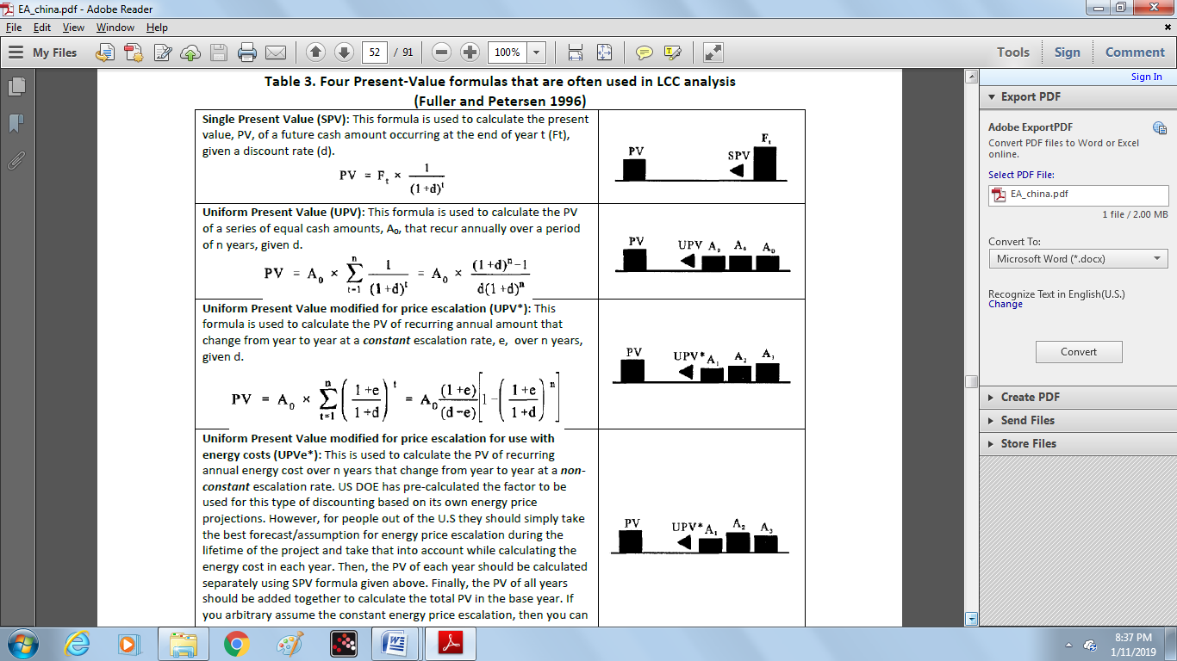

**Uniform Present Value modified for price escalation for use with energy costs (UPVe*)**: This is used to calculate the PV of recurring annual energy cost over n years that change from year to year at a ***non-constant*** escalation rate. US DOE has pre-calculated the factor to be used for this type of discounting based on its own energy price projections. However, for people out of the U.S they should simply take the best forecast/assumption for energy price escalation during the lifetime of the project and take that into account while calculating the energy cost in each year. Then, the PV of each year should be calculated separately using SPV formula given above. Finally, the PV of all years should be added together to calculate the total PV in the base year. If you arbitrary assume the constant energy price escalation, then you can use the UPV* formula given above.

To undertake a meaningful comparison of costs occurring at different points of time, those costs much be adjusted for changes in the purchasing power of the money (dollar, yuan, or any other currency) by estimating the future costs and saving in *constant* dollars (or any other currency) and using the *real* discount rate that excludes the rate of *Inflation*. In this case, if price escalation is needed, the *real* price escalation should be used as well. The formulas to convert *nominal* discount rate and escalation rate to *real* discount rate and escalation rate are given in equations 4 and 5, respectively.

d = (1+D)/(1+I) – 1 (Eq. 4)

*Where:*

“d” is the real discount rate, “D” is the nominal discount rate, and “I” is the inflation rate.

e = (1+E)/(1+I) – 1 (Eq. 5)

*Where:*

“e” is the real price escalation rate, “E” is the nominal price escalation rate, and “I” is the inflation rate.

**Cash-flow diagram**

A cash-flow diagram for a project provides a simple and clear way of visualizing all relevant costs and their timing. A horizontal timeline represents the study period or project lifetime and marks each year and key dates; e.g., the base date, the service date, and the end of the study period or lifetime of the project. There is no standard convention for showing costs on a cash flow diagram, but positive costs are typically shown above the horizontal timeline, and negative costs (e. g., residual values) are shown below the timeline. Initial investment costs, operation and maintenance costs, consumption-linked costs, and replacement costs are the general categories of the costs. The annual savings in consumption (energy, water, material, etc.) and savings in operation and maintenance costs are example of revenues.

**Formulas for LCC**

The general formula for a LCC present-value calculation is provided below:

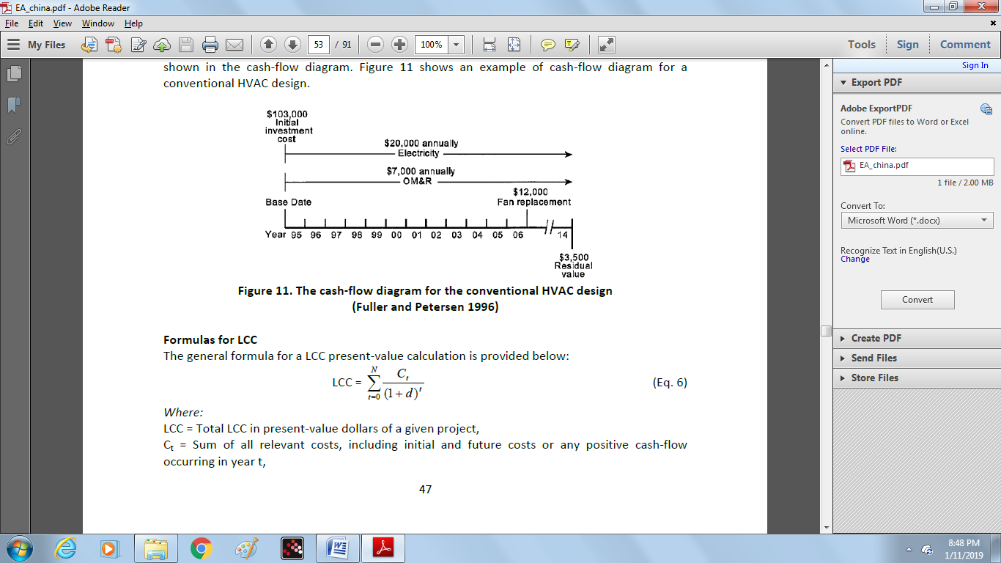

*Where:*

LCC = Total LCC in present-value dollars of a given project,

Ct = Sum of all relevant costs, including initial and future costs or any positive cash-flow occurring in year t,

N = Number of years in the study period, d = Discount rate used to adjust cash flows to PV.

The general LCC formula shown in Eq. 6 requires that all costs be identified by year and by amount. This general formula, while straightforward from a theoretical point of view, can require extensive calculations, especially when the study period is more than a few years long. A simplified LCC formula for energy efficiency projects in industry is shown in Eq. 7:

LCC = I + Repl - Res + E + W + OM&R (Eq. 7)

*where*:

LCC = Total LCC in present-value dollars of a given project,

I = Present-value of investment costs,

Repl = Present-value of capital replacement costs,

Res = Present-value of residual value (resale value, scrap value, salvage value) or disposal costs,

E = Present-value of energy costs,

W = Present-value of water costs,

OM&R = Present-value of non-fuel operation cost and maintenance and repair costs.

The LCC method provides a consistent way of accounting for all costs related to a particular energy-efficiency project over a given study period. In general, the LCCA is needed to demonstrate that the additional investment cost for a energy-efficiency project could be offset by its corresponding reduction in operating and maintenance costs (including energy and water costs), relative to the base case. Some of the key issues that should be taken into consideration when using the LCC method for project evaluation are:

• Choose among two or more mutually-exclusive alternatives on the basis of lowest LCC.

• All alternatives must meet established minimum performance requirements.

• All alternatives must be evaluated using the same base date, service date, study period, and discount rate.

• Positive cash flows (if any) must be subtracted from costs.

• Effects not measured in dollars must be either insignificant, uniform across alternatives,

or accounted for in some other ways (Fuller and Petersen 1996).

There are three supplementary methods of economic analysis that are consistent with the LCC method for project evaluation. These are net present value (NPV), internal rate of return (IRR) method, and savings-to-investment ratio (SIR) methods, which are explained below.

**8.3. Net present value (NPV) method**

The net present value (NPV) of a project is one of the basic economic criteria that are used for accepting or rejecting a project. Two conditions must be satisfied if a project is to be acceptable on economic grounds:

1. The expected present value of the net benefits (or net present value (NPV)) of the project must not be negative when discounted at an appropriate rate.

2. The expected NPV of the project must be at least as high as the NPV of mutually-exclusive alterative.

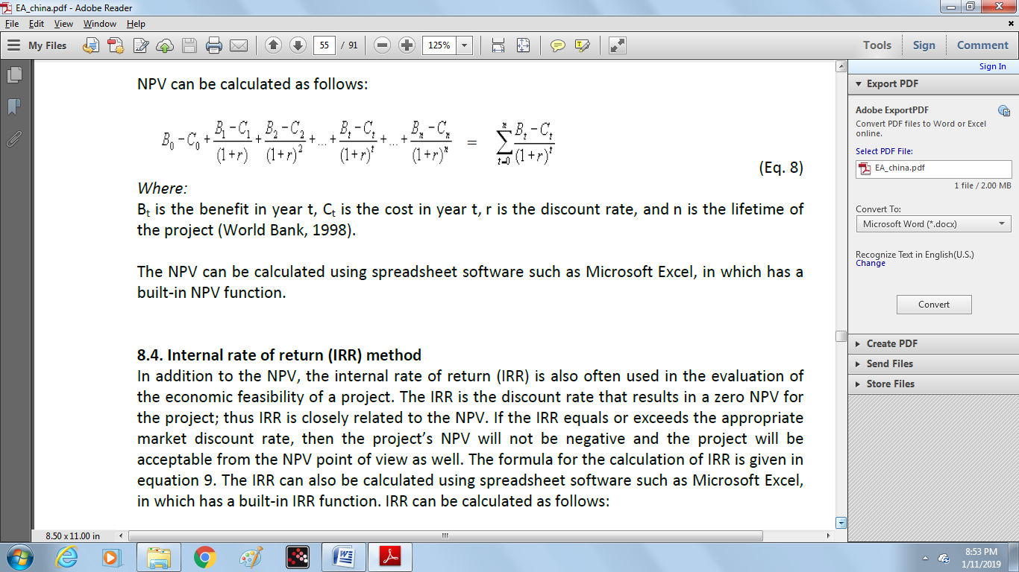

**8.4. Internal rate of return (IRR) method**

In addition to the NPV, the internal rate of return (IRR) is also often used in the evaluation of the economic feasibility of a project. The IRR is the discount rate that results in a zero NPV for the project; thus IRR is closely related to the NPV. If the IRR equals or exceeds the appropriate market discount rate, then the project’s NPV will not be negative and the project will be acceptable from the NPV point of view as well. The formula for the calculation of IRR is given in equation 9. The IRR can also be calculated using spreadsheet software such as Microsoft Excel, in which has a built-in IRR function. IRR can be calculated as follows:

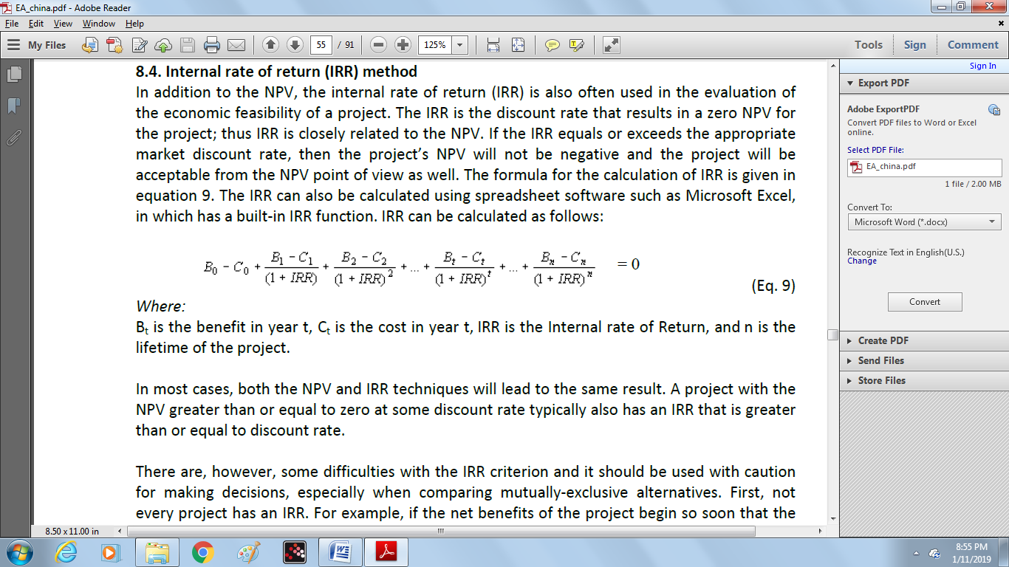

In most cases, both the NPV and IRR techniques will lead to the same result. A project with the NPV greater than or equal to zero at some discount rate typically also has an IRR that is greater than or equal to discount rate.

There are, however, some difficulties with the IRR criterion and it should be used with caution for making decisions, especially when comparing mutually-exclusive alternatives. First, not every project has an IRR. For example, if the net benefits of the project begin so soon that the project shows positive net benefits in every year, the IRR does not exist. Second, some projects may have more than one IRR. In these cases, the IRR method cannot be applied. Multiple IRRs arise when the project’s net benefits change sign more than once during the lifetime of the project. For example, a project that has negative net benefits during the first two years, positive net benefits during the next two years, negative net benefits again in the fifth year (perhaps because of new investments), and positive net benefits thereafter can have up to three IRRs. In general there can be as many IRRs as there are sign changes in the stream of net benefits.

**8.5. Simple payback period (SPP) method**

In contrast to the NPV and IRR methods, the simple payback period (SPP) calculation does not use discounted cash flows. The SPP also ignores any changes in prices (e. g., energy price escalation) during the payback period. The acceptable SPP for a project is typically set at an arbitrary time period often considerably less than its expected service period. SPP ignores all costs, savings, and any residual value occurring after the payback date. Payback is not a valid method for selecting among multiple, mutually-exclusive, project alternatives. The payback measures also should not be used to rank independent projects for funding allocation. In general, payback is best used as a screening method for identifying single project alternatives that are so clearly economical that the full LCC Analysis is not necessary.

**9. Preparing an energy audit report**

After finishing the energy audit, the audit team should write an energy audit report. In the report, the auditors should explain their work and the results in a well-structured format. The energy audit report should be concise and precise and should be written in a way that is easy for the target audience to comprehend. Some key issues that should be kept in mind while writing an audit report are:

• The audit report should be written in a way that provides suitable information to the potential readers of the report which could be the CEO or plant manager, the supervisor of engineering or maintenance, and the plant shift supervisor.

• The audit report should be concise and precise and use direct language that is easy to understand.

• Use more graphs rather than tables for the presentation of data, results and trends.

• The recommendation section should be specific, clear and with adequate detail.

• Assumptions made in the analysis should be explained clearly. How changes in the key assumptions can influence the results should also be explained. A sensitivity analysis is a very helpful tool for this.

• The auditors should do their best to avoid mistakes and errors in the report especially in the results. Even a few errors could damage the credibility of the audit.

• The energy audit report should be consistent in structure and terminology used.

• The calculations made in the analysis work should be explained clearly. An example of each type of calculation can be given either in the main body of the report or in appendix for more clarity.

Typical energy audit report contents and format are given below. The following format is applicable for thorough energy audit of a plant in most industries. However, the format can be modified for specific requirements applicable to a particular type of industry or energy audit.

**Typical content for an energy audit report:**

1. Executive Summary

1.1 Summary information on key audit findings (annual consumption and/or energy budget, key performance indicators, etc.)

1.2 Recommended energy-efficiency measures (with a brief explanation of each)

1.3 Implementation costs, savings and economic indicators (e.g. IRR, NPV, SPP) for the recommended measures

1.4 Any other useful information related to the implementation of energy-efficiency measures

2. Audit objectives, scope and methodology

3. Plant Overview

3.1 General plant details and description

3.2 Component of production cost (raw materials, energy, chemicals, man power, overhead, other)

3.3 Major energy use and the users

4. Production Process Description

4.1 Brief description of manufacturing process

4.2 Process flow diagram

4.3 Major raw material inputs, quantities, and costs

5. Energy and Utility System Description

5.1 List of utilities

5.2 Brief description of each utility (any of the following that are applicable)

5.2.1 Electricity

5.2.2 Steam

5.2.3 Water

5.2.4 Compressed air

5.2.5 Chilled water

5.2.6 Cooling water

5.2.7 Process heating

6. Detailed Process Flow Diagram and Energy & Material Balance

6.1 Flowchart showing flow rate, temperature, and pressures of all input-output streams

6.2 Water balance for major units in the facility

7. Energy Use Analysis in Utility and Process Systems (any of the following that are applicable)

7.2 Boiler efficiency assessment

7.3 Furnace/kiln efficiency analysis

7.4 Cooling water system performance assessment

7.5 Refrigeration system performance

7.6 Compressed air system performance

7.7 Summary of load inventory results

8. Energy Use and Energy Cost Analysis in the Plant

8.1 Specific energy consumption

8.2 Summary of energy bills analysis results

8.3 Summary of the results from the analyzing the energy use and production patterns

8.4 Summary of the results from the benchmarking analysis

8.5 Summary of assumptions and samples for all important calculations

9. Energy-Efficiency Options and Recommendations

9.1 List of energy-efficiency options classified in terms of no cost/low cost, medium cost, and high investment cost along with their annual energy and cost savings

9.2. Summary of the cost-benefit analysis of energy-efficiency measures

10. Conclusion and a brief action plan for the implementation of energy-efficiency options

Acknowledgements

Appendixes

A1. List of energy audit worksheets

A2. List of vendors for energy-efficient technologies and other technical details.

**10. Post-audit activities**

**10.1. Create an action plan for the implementation of energy-efficiency measures**

In practice there are often barriers that prevent the successful implementation of energy-efficiency measures recommended in an energy audit report. Therefore, it is helpful to establish a clear procedure to ensure the successful realization of recommended improvements. An implementation action plan should be described in a simple way with clear goals, saving targets, and definitions of roles and responsibilities for its execution.

A detailed action plan helps to ensure a systematic process to implement energy-efficiency measures. The action plan can be updated regularly, most often on an annual basis, to reflect recent achievements, changes in performance, and shifting priorities. While the scope and scale of the action plan is often dependent on the organization, the steps below outline a basic starting point for creating a plan:

1. Define technical steps and targets

2. Determine roles and resources

Before finalizing the action plan, it is better to consult with plant managers and key engineers to get their input on the action plan.

**Define Technical Steps and Targets:**

The energy audit results can provide an indication of the technical performance of the plant and its gap with the efficient performance. Based on this, opportunities for energy-efficiency improvement can be identified and prioritized. Three key steps are:

• **Create performance targets** for each facility, department, and operation of the organization to track progress towards achieving the goals.

• **Set timelines** for actions, including regular meetings among key personnel to evaluate progress, completion dates, milestones and expected outcomes.

• **Establish a monitoring system** to track and monitor the progress of actions taken. This system should track and measure energy use and project/program activities.

**Determine Roles and Resources:**

*Identify internal roles*

The action plan should determine who is involved in the energy-efficiency program and what their responsibilities are. Depending on the organization and action plan, this might include departments such as:

• Facility and operations management

• Financial management - capital investments, budget planning

• Human resources - staffing, training, and performance standards

• Maintenance

• Supply management - procurement procedures, energy purchasing and equipment and materials

• Building and plant design

• Engineering

• New product/process development teams

• Communications Marketing

• Environmental, Health, and Safety

*Identify external roles*

The action plan should determine the degree to which consultants, service providers, vendors, and other product providers will be used. Some organizations may choose to outsource entire aspects of their action plan while others may only want to contract with specific vendors for limited projects. If contractors will be used, the action plan should determine what standards will be used to evaluate bids and incorporated these metrics into agreements with contractors.

*Determine Resources*

For each project or program in the action plan, estimate the cost for each item in terms of both human resources and capital/expense. Then, develop the business case for justifying and gaining funding approval for action plan projects and resources need.

**10.2. Implement the action plan**

To successfully implement the action plan, it is vital to gain support from the personnel within the plant involved in the energy-efficiency improvement programs. To implement the action plan, the following steps should be considered:

1. Create a communication plan: Develop targeted information for key audiences about the energy efficiency action plan

2. Raise awareness: Build support for all levels of the organization for energy efficiency initiatives and goals.

3. Build capacity: Through training, access to information, and transfer of successful practices, and procedures to expand the capacity of the plant staff.

4. Motivate: Create incentives that encourage staff to improve energy performance to achieve goals.

5. Track and monitor: Use the tracking system developed as part of the action plan to track and monitor progress regularly.

**Evaluate Progress:**

Plant managers can evaluate the progress of their activities using energy data and a review of the activities taken as part of the action plan, comparing them to the established goals. This review can be used to revise the action plan and see the lessons learned. Regular evaluation of energy performance and the effectiveness of energy-efficiency initiatives also allows energy managers to:

• Measure the effectiveness of projects and programs implemented

• Make informed decisions about future energy projects

• Reward individuals and teams for accomplishments

• Document additional savings opportunities as well as non-quantifiable benefits that can be leveraged for future initiatives.

It worth highlighting the fact that a company needs to have an energy management program to be able to fully benefit from the energy audit results and to have sustainable energy efficiency improvement. If it does not have an energy management program, the audit will likely be a one-time event, and the implementation rate of the audit recommendations will be low.

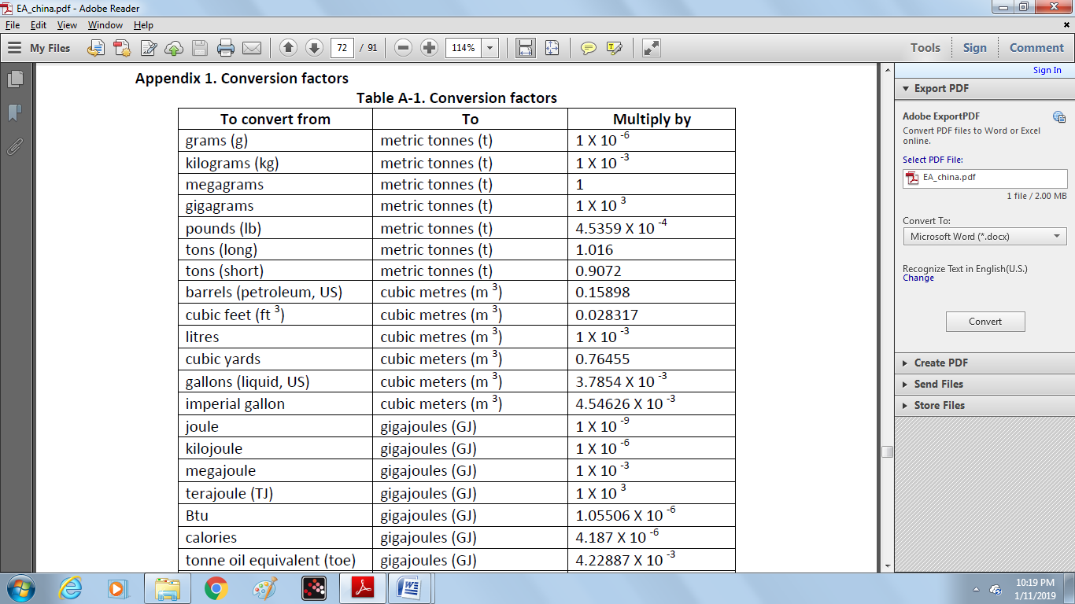

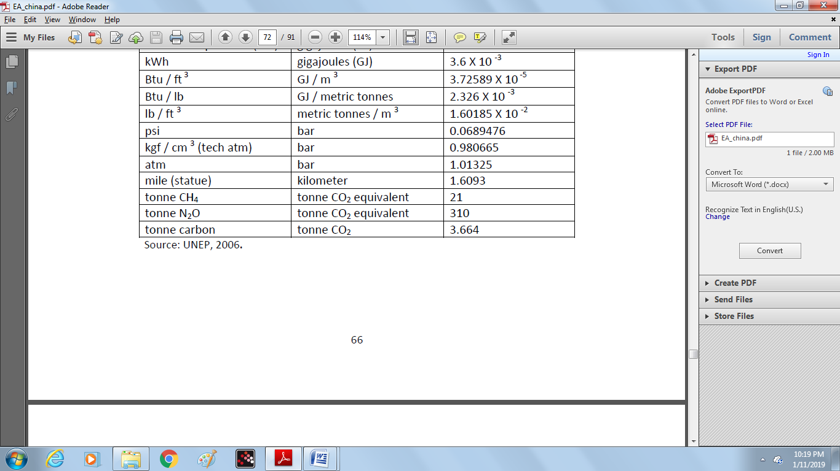

**Energy audit instruments**

**A.2.1. Safety considerations**

An energy audit of an industrial plant requires working on-site, close to utility and production machinery. Safety considerations are a very important part of any industrial energy audit. The audit team should be thoroughly briefed on safety equipment and procedures and should never put themselves in a dangerous situation while conducting the audit. Auditors should be extremely careful making any measurement on electrical systems or high temperature devices such as boilers, heaters, etc. Electrical or asbestos gloves should be worn as appropriate.

The auditors should also be very careful when examining any operating piece of equipment, especially those with open drive shafts, belts or gears, or any form of rotating machinery. The equipment operator or supervisor should be notified that the auditor is going to look at the equipment and might need to get information from some parts of the machine. The auditor should never approach a piece of equipment and inspect it without the operator or supervisor being notified in advance (Turner and Doty 2007). A safety checklist can be itemized as follows:

**Electrical**

• Avoid working on live circuits if possible.

• Securely lock off circuits and switches before working on a piece of equipment.

• Always try to keep one hand in your pocket while making measurements on live circuits to help prevent cardiac arrest.

**Respiratory**

• When necessary, wear a full face respirator mask with adequate filtration particle size.

• Use activated carbon cartridges in the mask when working around low concentrations of noxious gases. Change the cartridges on a regular basis.

• Use a self-contained breathing apparatus for work in toxic environment

**Hearing**

• Use foam insert plugs while working around loud machinery to reduce sound levels to 30 decibels.

**A.2.2. Measuring electrical parameters**

For measuring the electrical parameters the following instrumentation are included:

1. Ammeter: measures the current absorbed by motors/machines.

2. Voltmeter: measures the voltage or voltage drop in the grid or electrical circuits.

3. Watt-meter: measures instant power demand of motors/ machines or the power performance of generators.

4. Cosö-meter: measures the power factor or monitors the rectification devices.

5. Multi-meter: measures all the above quantities and some other quantities (e.g. frequency, reactivity, phase angle, etc)

All of the above instruments are usually portable. They are connected to the wiring with the use of nippers and they could feature a data-logger. Measurements of electrical power and energy consumption should be made on all energy-intensive areas and installations.

During the measurement of all the above quantities, the total power (metered in kVA) and the active power (usually metered in kW) should be distinguished. Care is also needed with electrical loads that are not expected to present a sinusoidal waveform, like variable speed drives (VSDs). Common measuring instrumentation is based on a sinusoidal waveform, which gives incorrect readings for VSDs. In such cases, the use of meters measuring real RMS (Root Mean Square) values is necessary. The function of such meters is based on digital sampling.

Measurement of electrical parameters requires use of a complex instrument called a power analyzer. After the instrument’s proper connection to the electrical panel of machinery or the substation under examination, measurement readings are presented on its display, which include instantaneous and programmable duration measurements for each phase and for the total voltage, current, apparent reactive and active power, cosö and energy consumption. The instantaneous measurements are repeated every 20 seconds.

**A.2.3. Temperature measurement**

The most common temperature measuring technologies include:

a) Resistance Thermometer Detectors (RTD): One of the most technologically-advanced instruments with internal signals for calibration and resetting and a high level of accuracy.

b) Thermocouples: Widely used and not expensive, covering a wide range of temperatures, from a few degrees up to 1000 °C and are usually portable. They need frequent calibration with specialized instruments. Their main disadvantage is that they have a weak signal, easily affected by industrial noise.

c) Thermistors: Used as permanent meters and are of low cost and have an automatic resetting capability.

d) Infrared thermometers: Measure temperatures from a distance by sensing the thermal radiation. They sense “hot-spots” and insulation problem areas. Portable and easy to use, but with limited accuracy.

Infrared thermometers are becoming more common in industry. The infrared camera (Figure A-2) is equipped with a sensor which converts the infrared radiation from the surface to voltage difference and through appropriate software converts the voltage difference to an image having a color spectrum corresponding to radiation levels.

|  |  |
| --- | --- |
| Before auditing the heating systems (e.g. boilers), the equipment should operate at its normal temperatures, so that data coming from the measurements can be the representative of actual performance. The camera should operate for about 5 minutes before any measurements are taken, to ensure that the automatic self-calibration is completed. In order to determine the heat losses from the building’s shell, as well as the locations where insulation is degrading, the indoor temperature should be higher than the outdoor temperature. Thus, a cold and cloudy day should be chosen in order to avoid the heating effect on walls by incident radiation. | **Figure A-2. Non-contact or Infrared Thermometer** |

**A.2.4. Flow measurements**

To estimate heat flow through a fluid, it is necessary to measure its flux (mass or volume). Such measurements typically include air and liquid fuel, steam and hot or cold water, or airflow measurements. Combining a measurement of temperature difference with flow measurement allows for the measurement of the thermal and energy flows. The meter should be carefully selected, taking into account the fluid type, any diluted and corrosive substances, the speed range and the relevant costs. Flow-metering sensors can be classified as follows:

|  |  |
| --- | --- |
| • Differential pressure meters (of perforated diaphragm, Venturi or Pitot tube type)  • Interference meters (of variable cross section, positive shift, eddy or vortex metering type)  • Non-interference meters (of ultrasonic or magnetic meter)  • Mass meters (of Coriolis or angular momentum type)  Pitot tubes are usually accompanied with an electric manometer for speed measurement. Ultrasonic meters technology has also progressed, offering a high accuracy. They require relatively pure fluids and are easy to use. They are installed simply on the measured tubing (Figure A-3). The instruments should be used according to the manufacturer’s catalog and they also should be calibrated regularly |  |

**A.2.5. Exhaust gas measurements**

Exhaust gas measurements include CO2, CO, SOx, NOx, smoke content, and temperature measurement. Traditionally, these measurements are taken with low cost portable instruments. Electronic gas analyzers are available today, which can rapidly measure all the above quantities and, at the same time, perform calculations for the combustion efficiency (Figure A-4).

|  |  |
| --- | --- |
| The traditional measurement instruments measure under dry gas conditions, while the electronic ones measure the gases composition continuously and under real time conditions. Thus, this should be taken into account while comparing the results. Moreover, before taking any on-site measurements, the boiler should operate for some time in order to reach its standard operating temperature. The sampling probe of the gas analyzer is inserted in the chimney and its end must be placed in the middle of the core of the exhaust gases (the middle of the chimney). This can be achieved accurately because modern gas analyzers have the capability of displaying the temperature of any point that the probe is located. Therefore, the appropriate sampling point is located where maximum temperature occurs, right in the middle of the gas flow. | **Figure A-4. Gas analyzer** |

Once proper sampling is achieved, gases are analyzed by the gas analyzer and the percentage of the exhaust gases in CO, CO2, O2, SO2, NOx, CxHx is determined through built-in algorithms. Modern gas analyzers are fully automatic so that when the proper sample is taken, the boiler efficiency and the percentage of the above mentioned gases are shown on the display of the gas analyzer.

**A.2.6. Measurement of the speed of rotating equipment**

Speed measurements of for example motors are critical as they may change with frequency, belt slip and loading. There are two main types of speed measurement instruments: tachometer and stroboscope (Figure A-5). In a contact-type tachometer, the wheel of the tachometer gets in contact with the rotating body. Due to friction between the two, after few seconds the speed of the wheel of the tachometer is the same as the speed of the rotating body. This speed is displayed on the panel as rpm (rotations per minute).

|  |  |
| --- | --- |
| The digital stroboscope is a flashing light source that is used to measure the speed of fast- moving objects or to produce the optical effect of stopping or slowing down high-speed motion for purposes of observation, analysis, or high-speed photography. When measuring the rotational speed of an object, set the flash rate initially to a higher setting than the estimated speed of the object. Then, slowly reduce the flash rate until the first single image appears. At this point, the strobe flash rate is equal to the rotational speed of the object, and the speed can be read directly from the digital display | **Figure A-5. A tachometer (left) and a stroboscope (right)** |